21/9/23

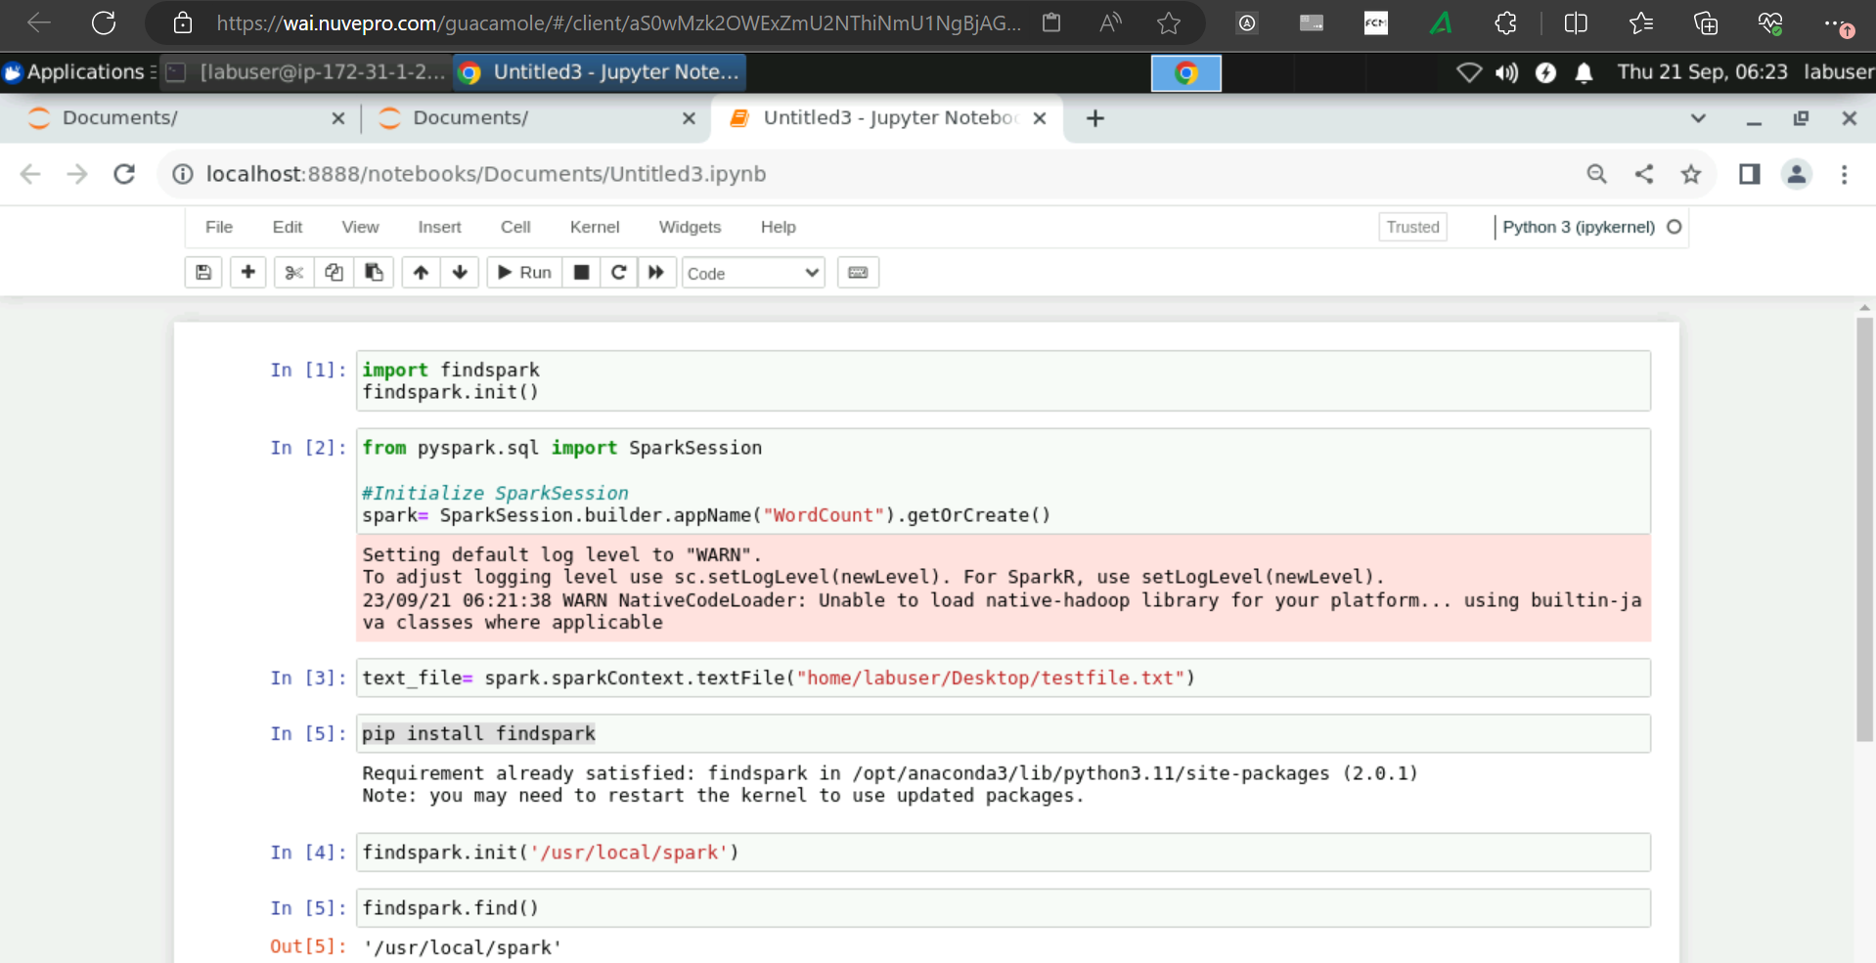

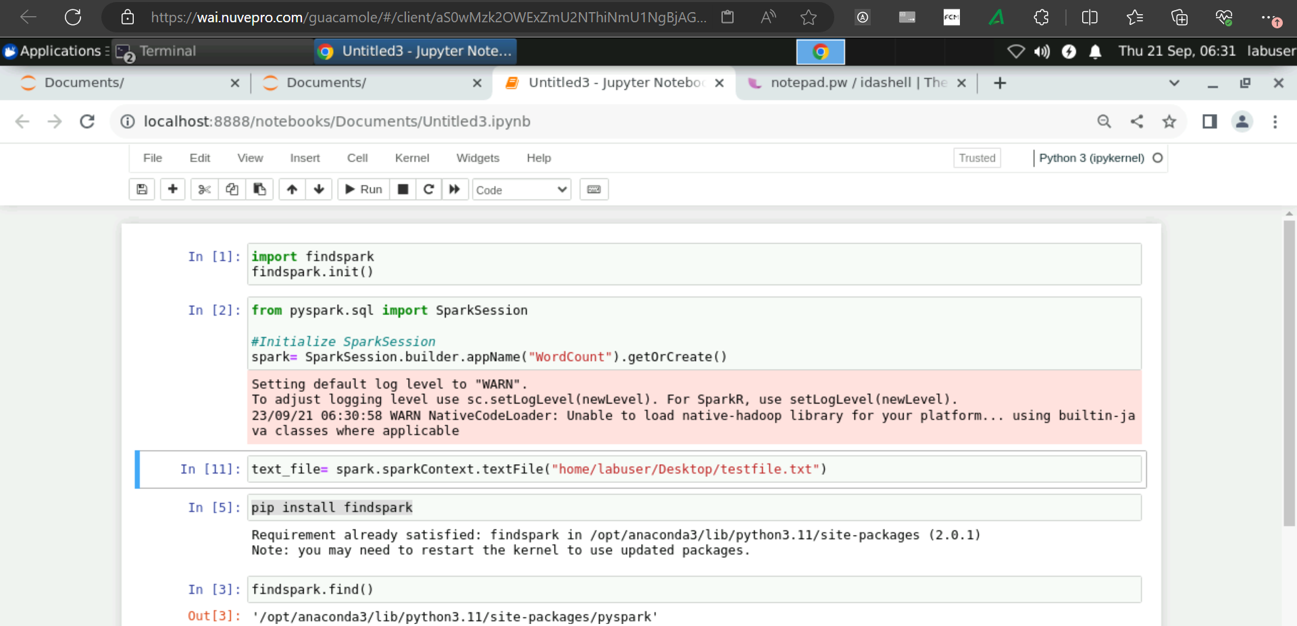

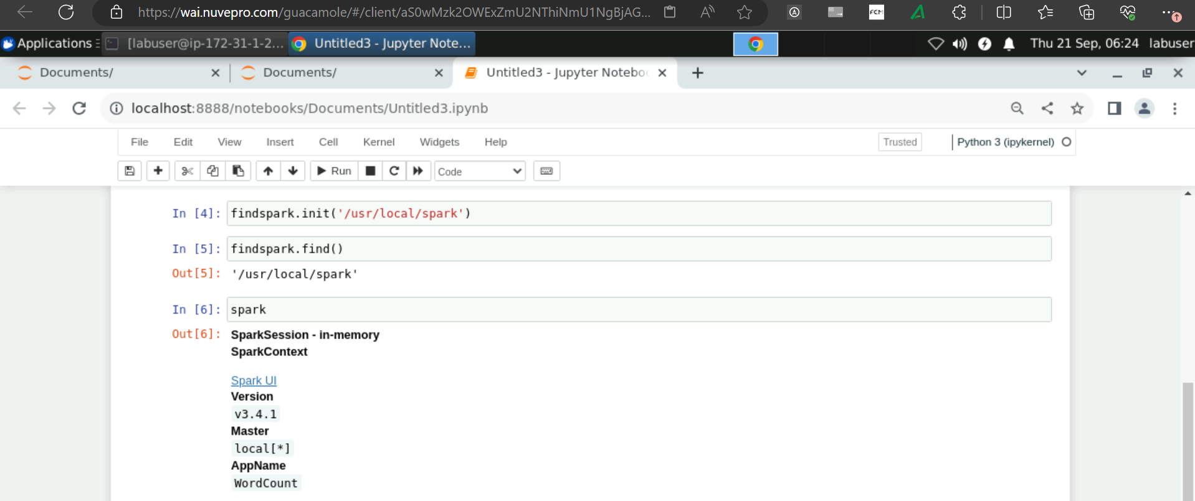

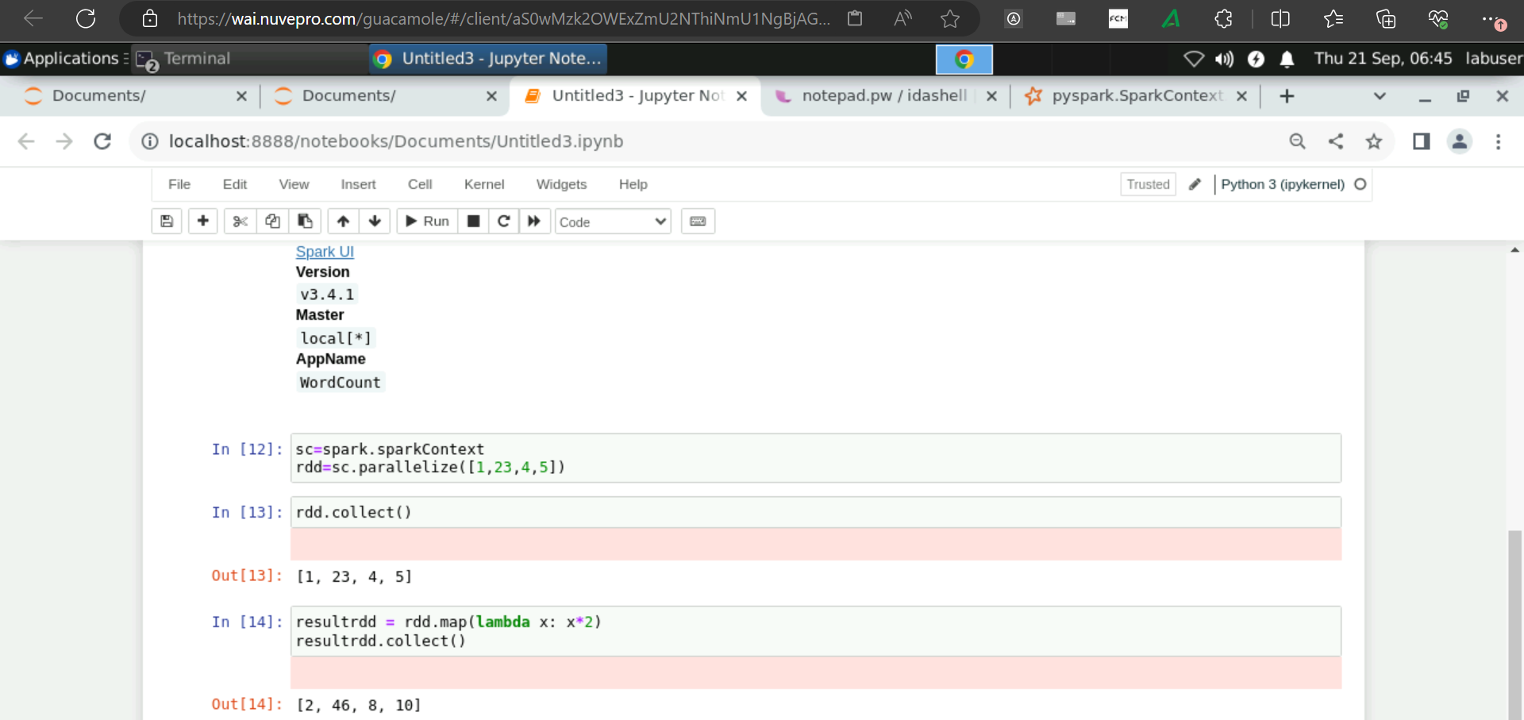

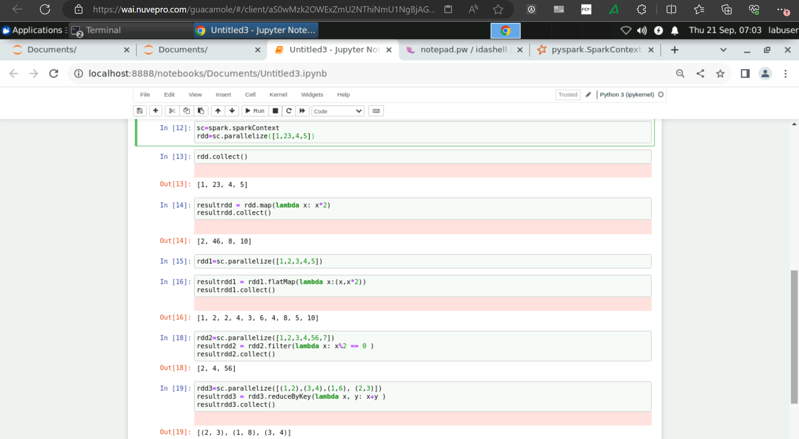

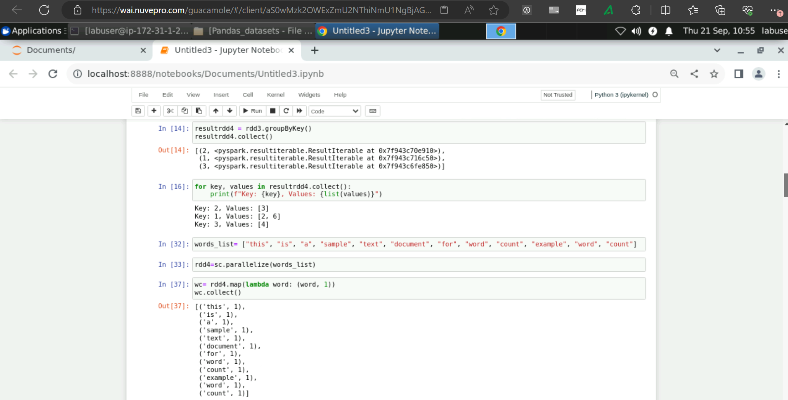

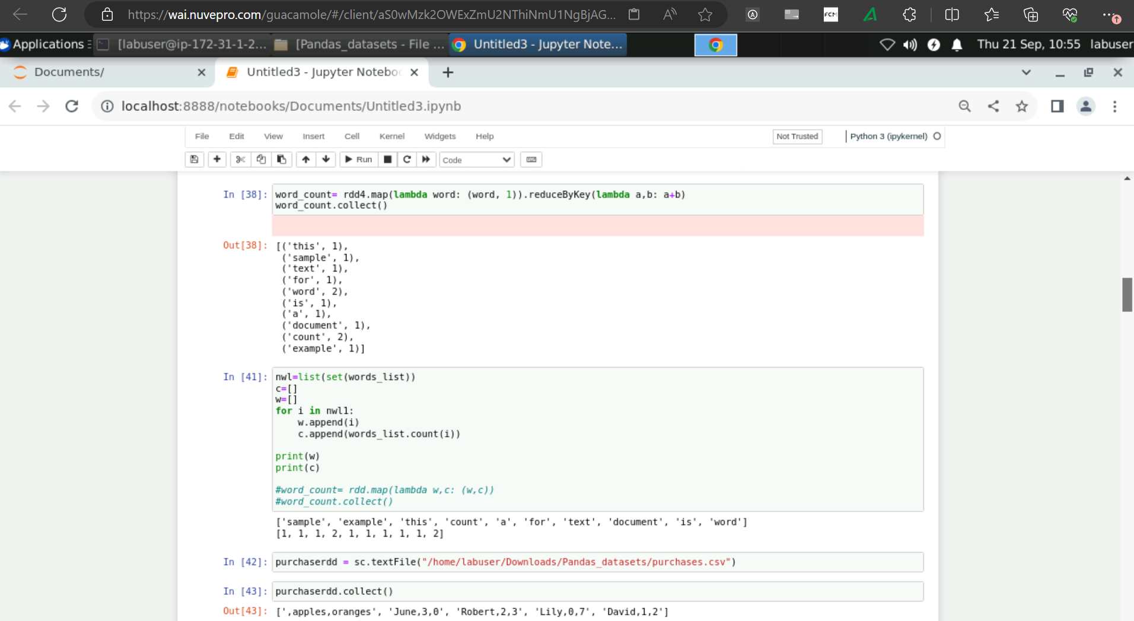

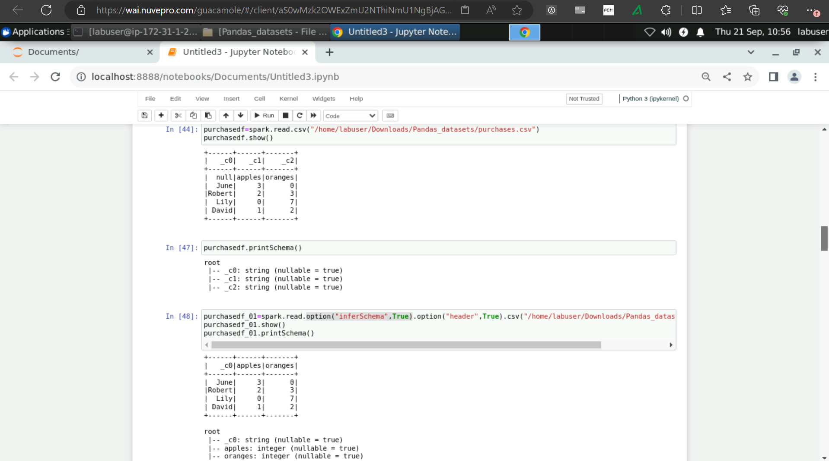

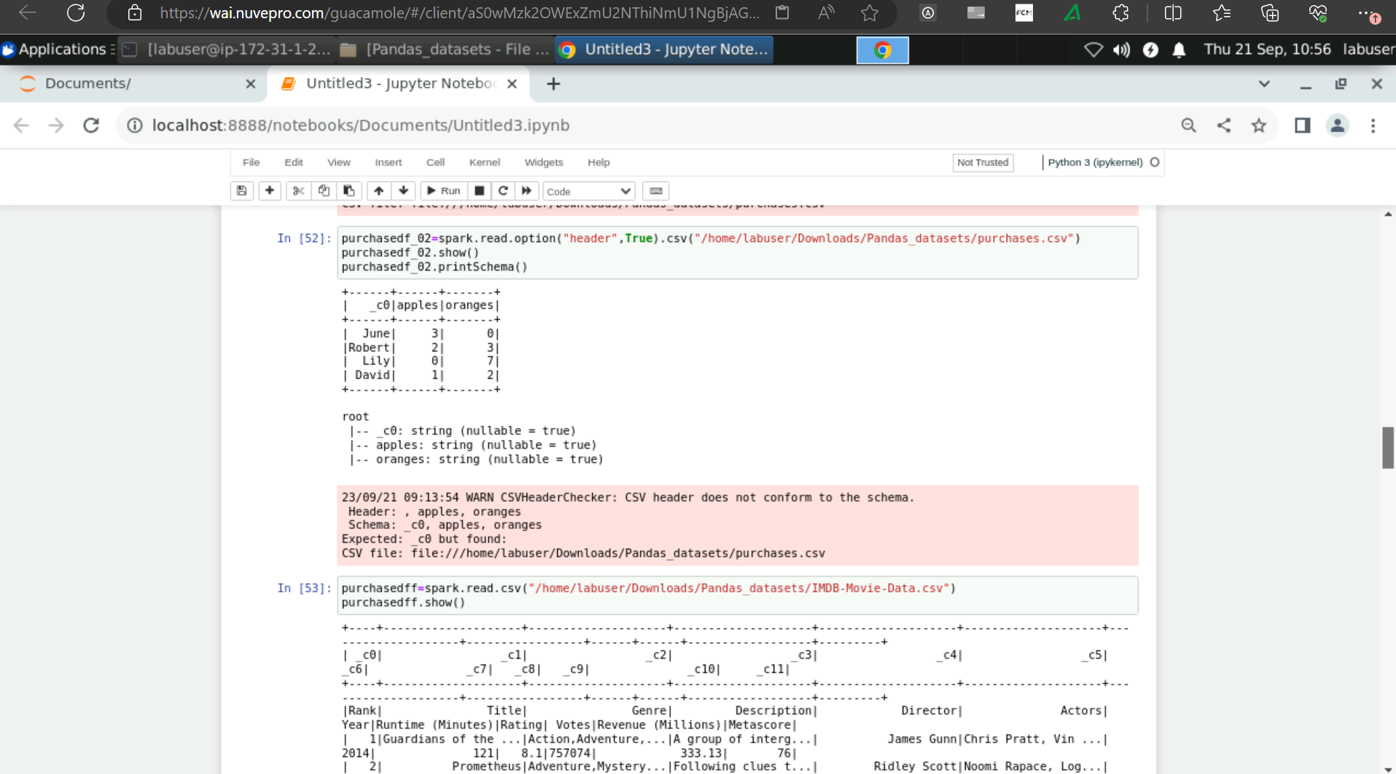

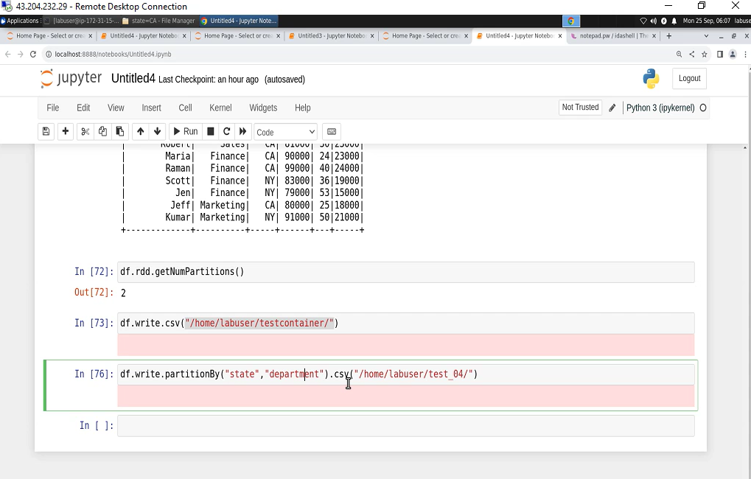

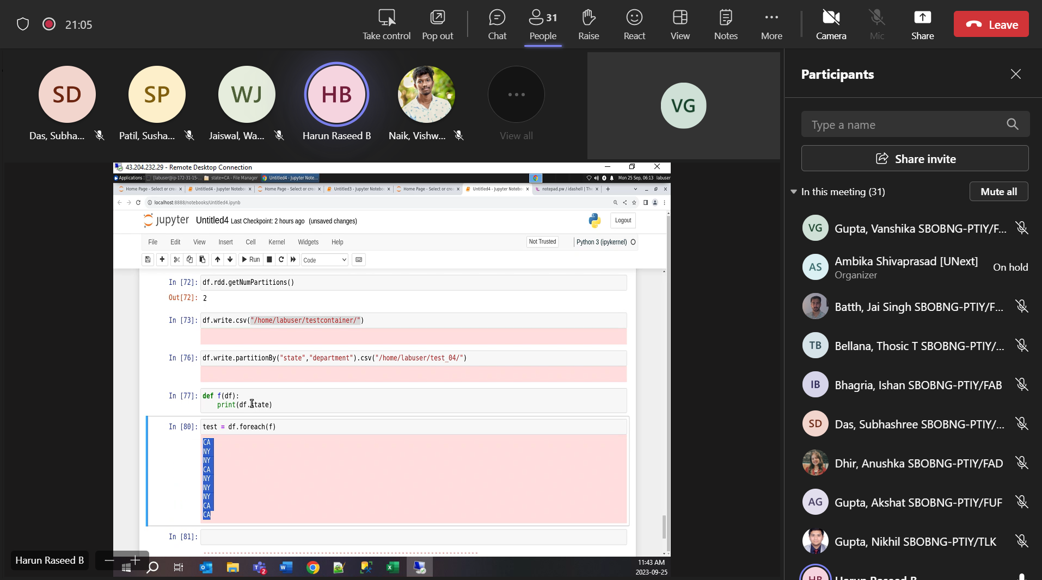

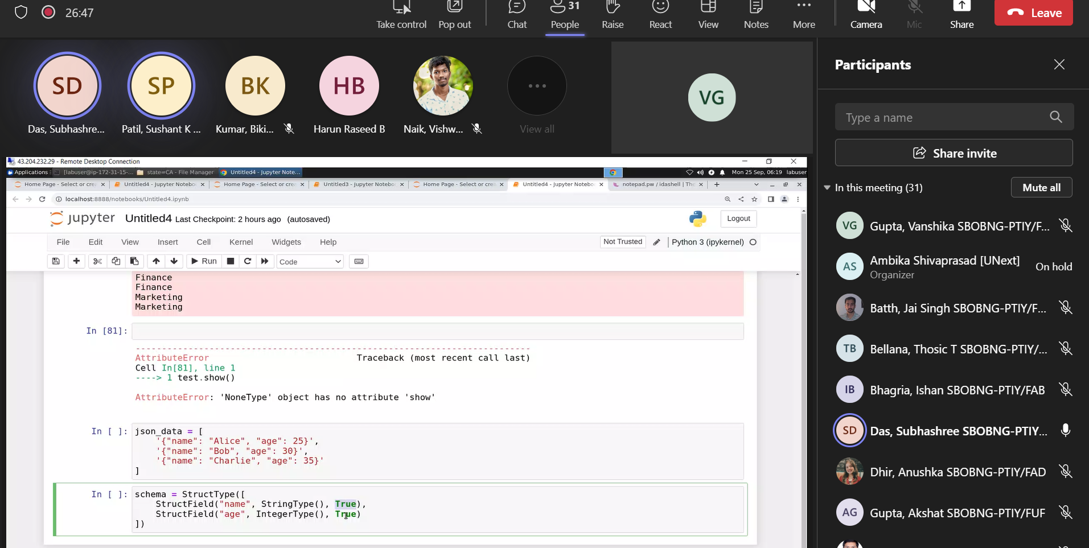

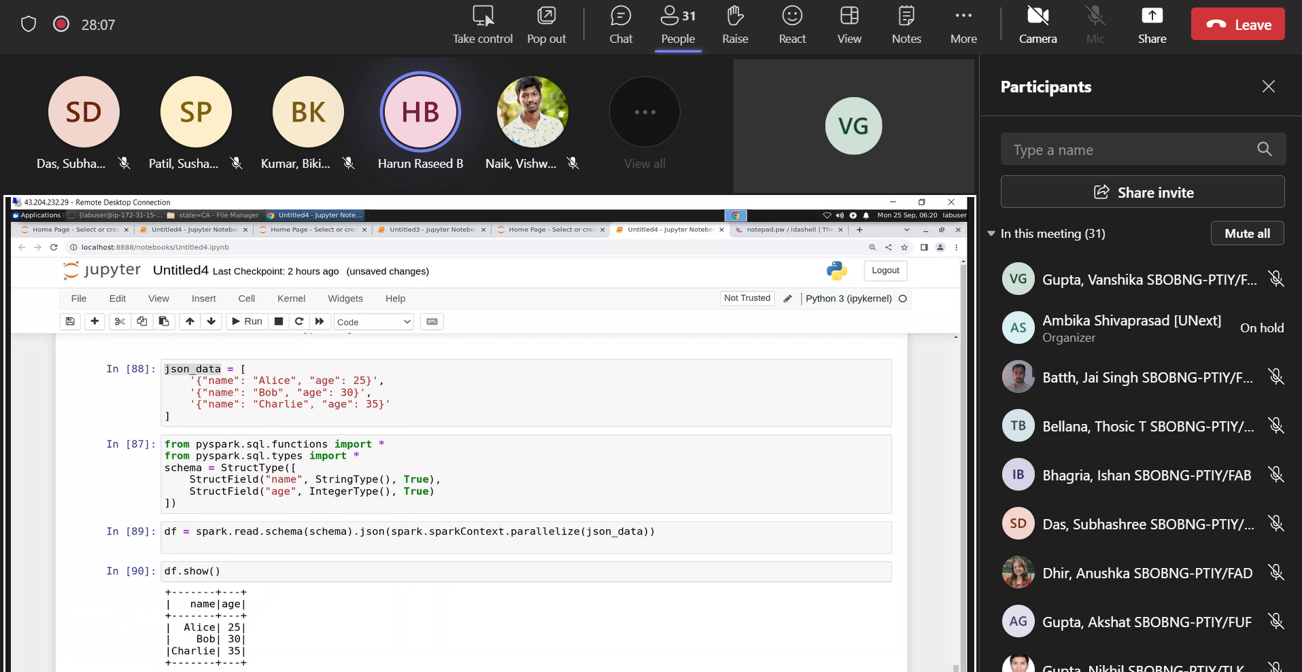

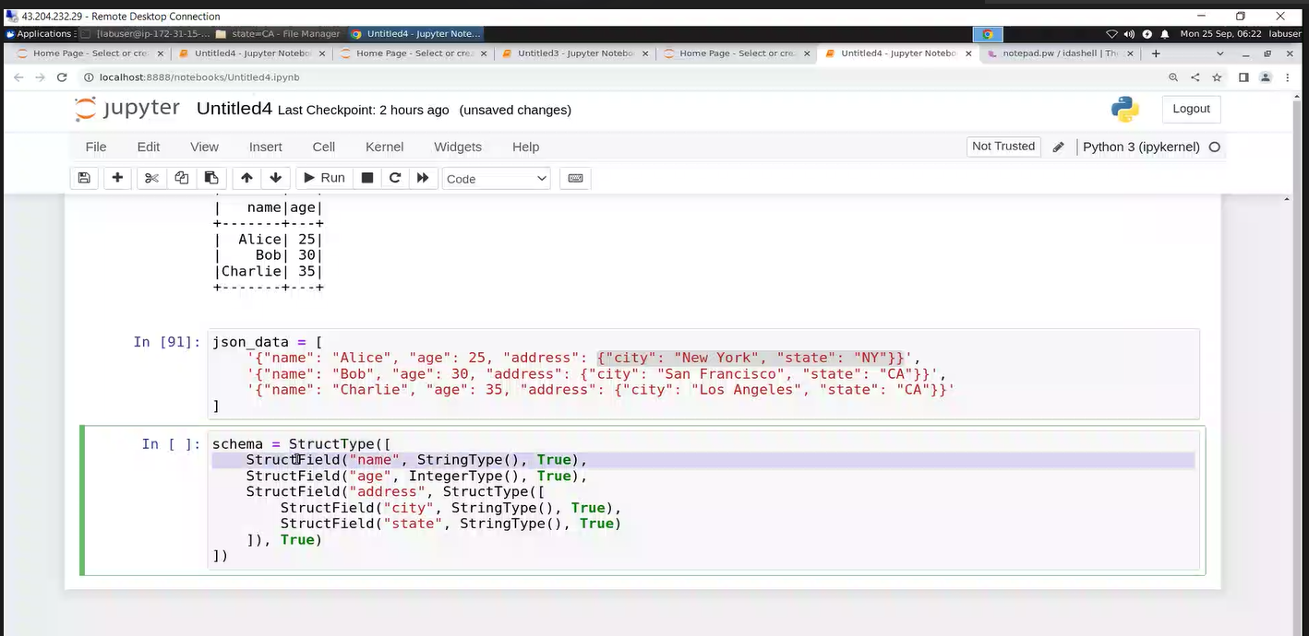

test_df = purchasedf_01.withColumn("rating_value", when(col("Rating")>=2,"Average").when(col("Rating")>=5,"Good").otherwise("NA")) )

test_data = [("James","Sales","NY",90000,34,10000),

("Michael","Sales","NY",86000,56,20000),

("Robert","Sales","CA",81000,30,23000),

("Maria","Finance","CA",90000,24,23000),

("Raman","Finance","CA",99000,40,24000),

("Scott","Finance","NY",83000,36,19000),

("Jen","Finance","NY",79000,53,15000),

("Jeff","Marketing","CA",80000,25,18000),

("Kumar","Marketing","NY",91000,50,21000)

]

ud_scehma = ["employee_name","department","state","salary","age","bonus"]

df = spark.createDataFrame(data=test_data ,schema = ud_scehma)

To solve the Spark Version Error:she;;

import os

import sys

os.environ['PYSPARK_PYTHON'] = sys.executable

os.environ['PYSPARK_DRIVER_PYTHON'] = sys.executable

****************

json_data = [

'{"name": "Alice", "age": 25}',

'{"name": "Bob", "age": 30}',

'{"name": "Charlie", "age": 35}'

]

from pyspark.sql.functions import *

from pyspark.sql.types import *

schema = StructType([

StructField("name", StringType(), True),

StructField("age", IntegerType(), True)

])

df = spark.read.schema(schema).json(spark.sparkContext.parallelize(json_data))

****************************8

json_data = [

'{"name": "Alice", "age": 25, "address": {"city": "New York", "state": "NY"}}',

'{"name": "Bob", "age": 30, "address": {"city": "San Francisco", "state": "CA"}}',

'{"name": "Charlie", "age": 35, "address": {"city": "Los Angeles", "state": "CA"}}'

]

schema = StructType([

StructField("name", StringType(), True),

StructField("age", IntegerType(), True),

StructField("address", StructType([

StructField("city", StringType(), True),

StructField("state", StringType(), True)

]), True)

])

df = spark.read.schema(schema).json(spark.sparkContext.parallelize(json_data))y

26/9/23

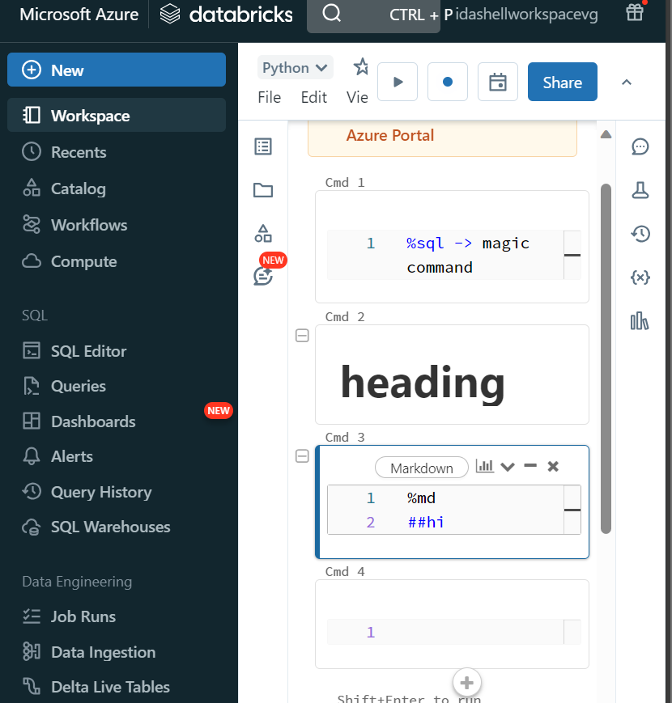

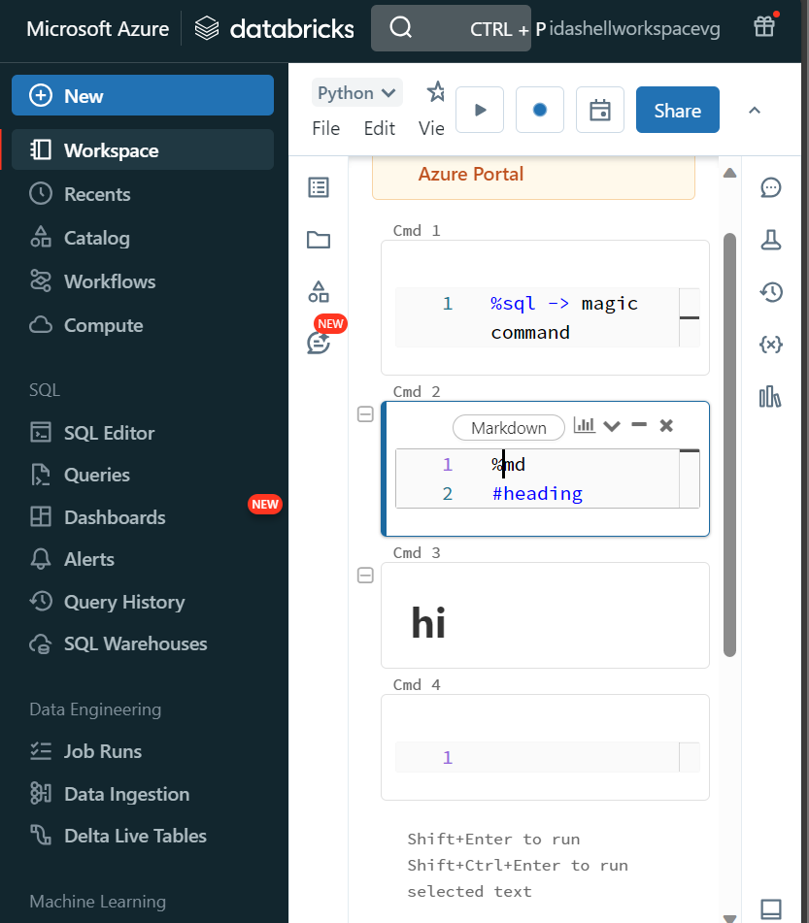

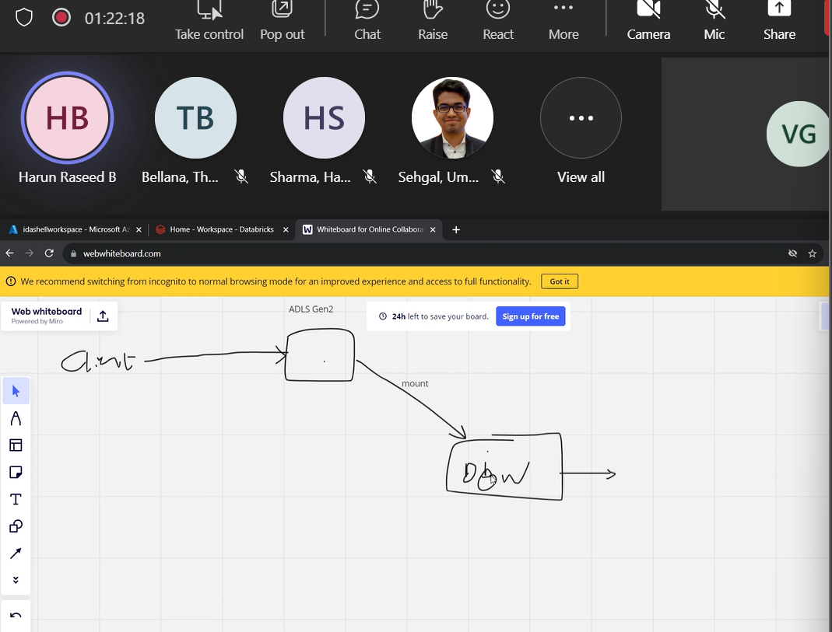

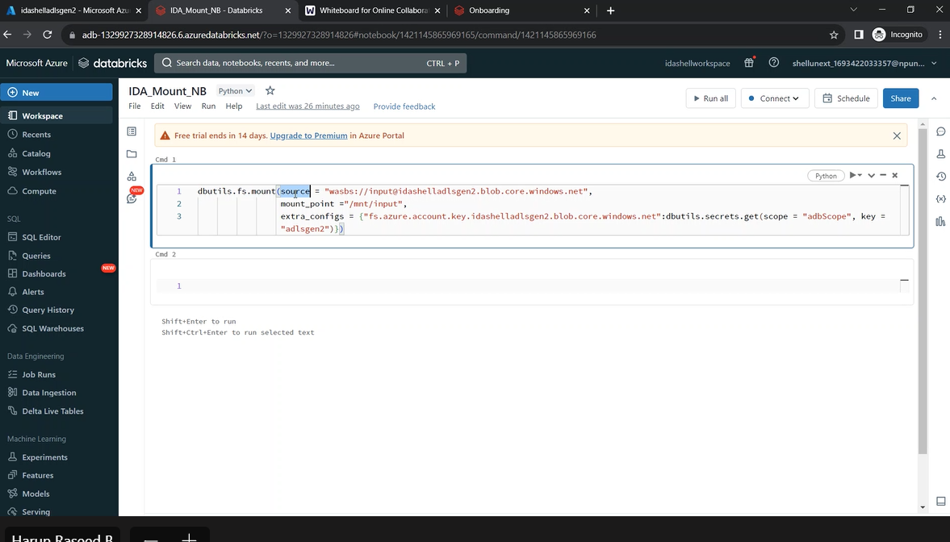

dbutils.fs.mount(source = "wasbs://input@vgshellidagen01.blob.core.windows.net",

                 mount_point= ("/mnt/input"),

                 extra_configs = {"fs.azure.account.key.vgshellidagen01.blob.core.windows.net":dbutils.secrets.get(scope= "adbScope", key="adlsgen2")})

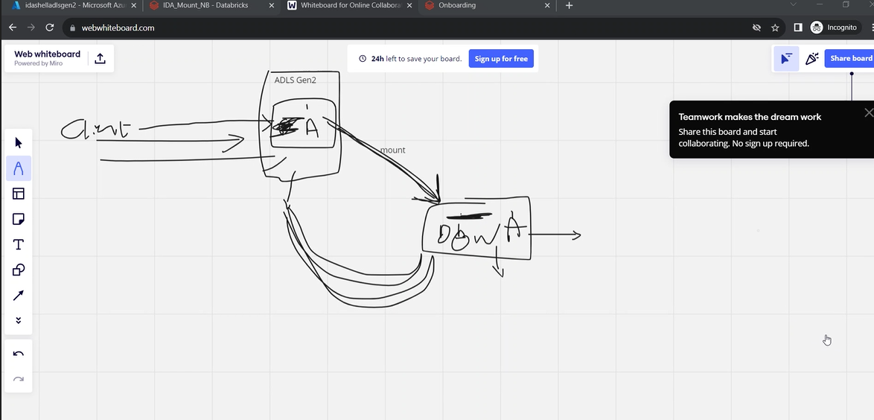

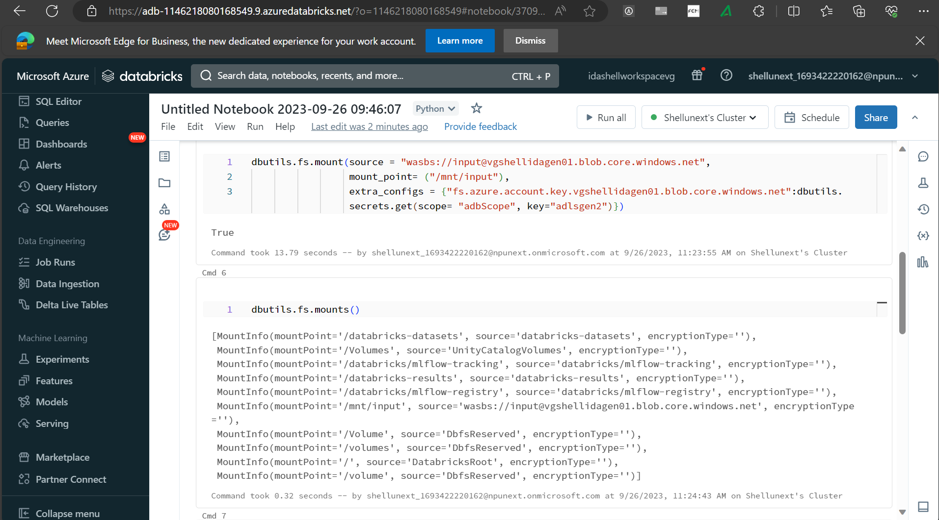

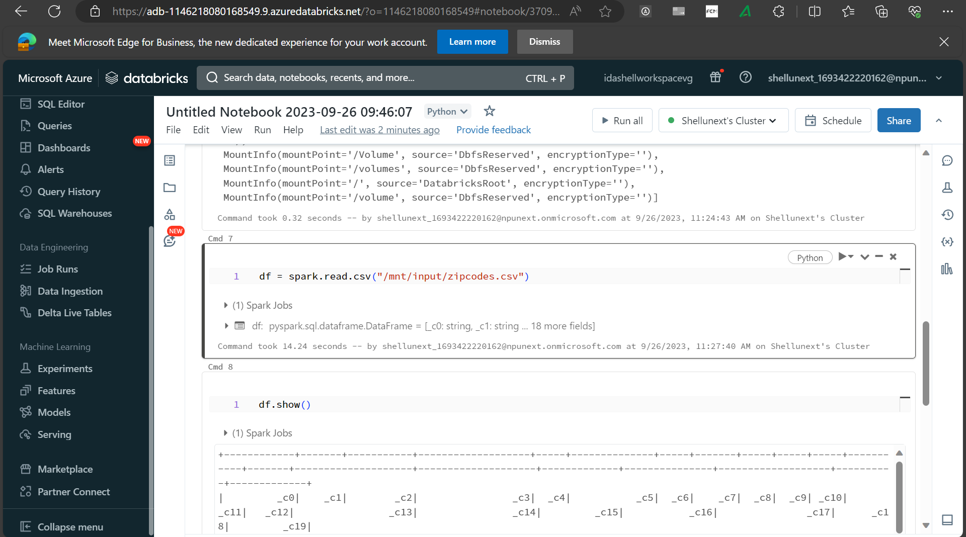

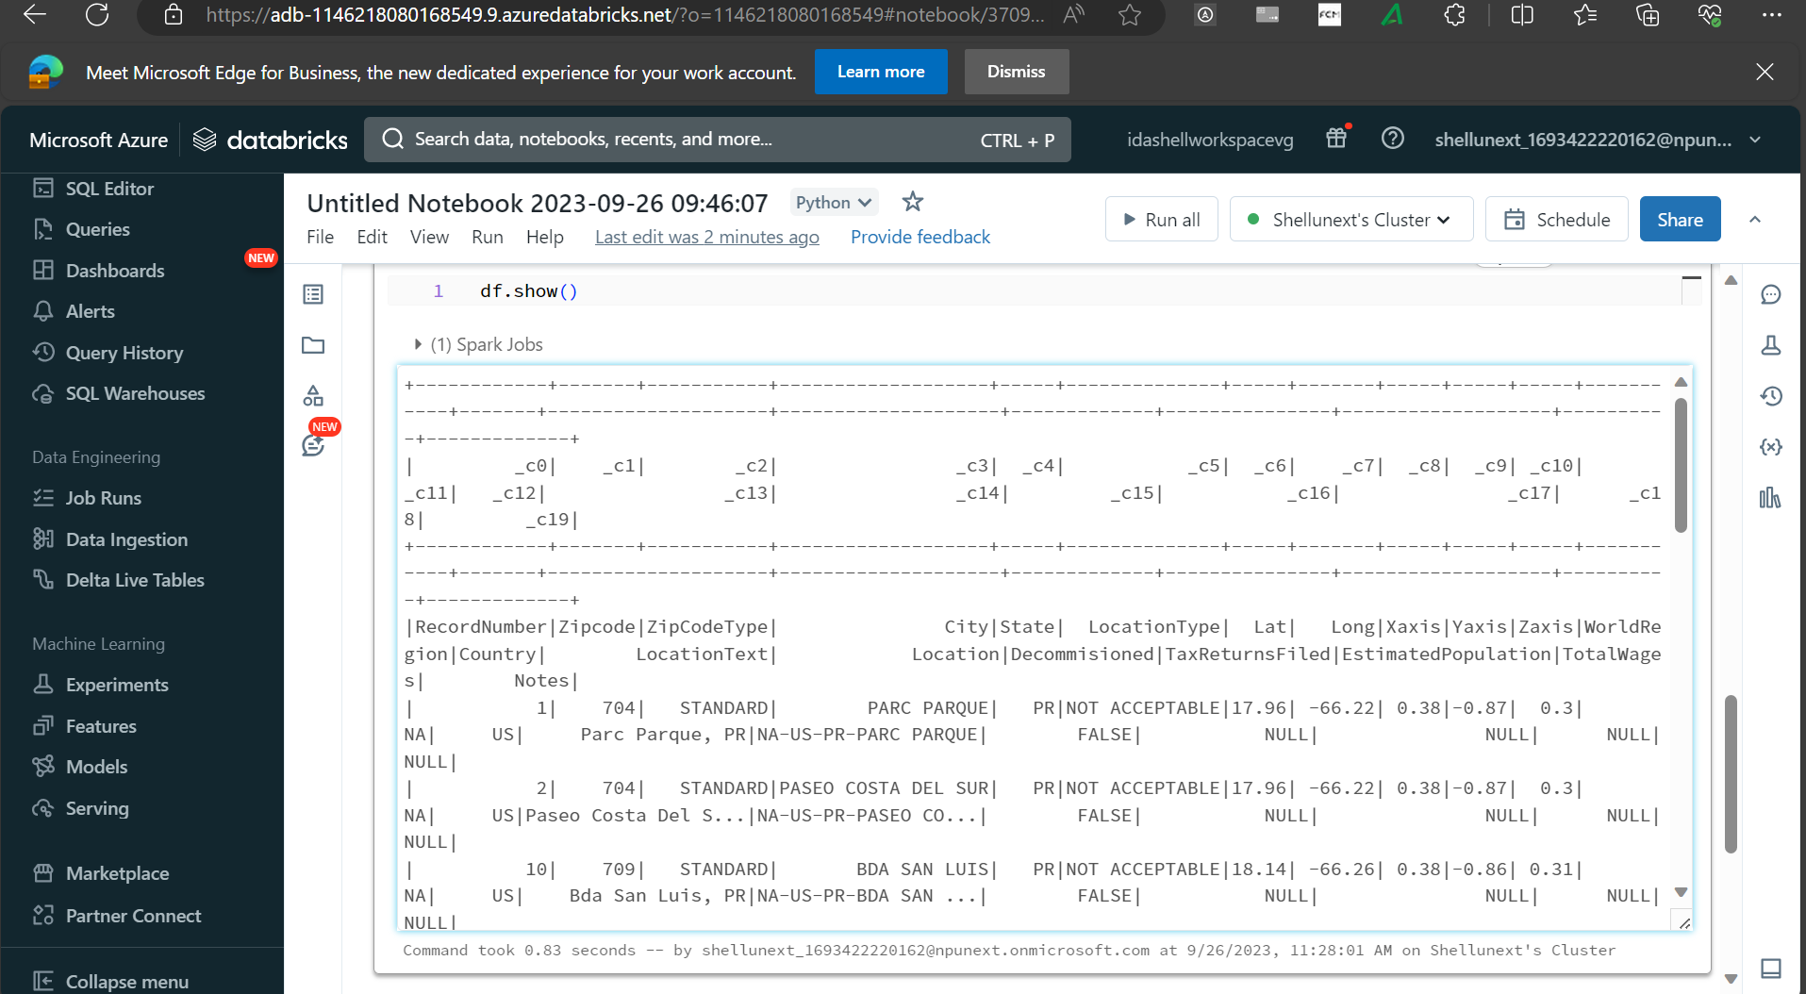

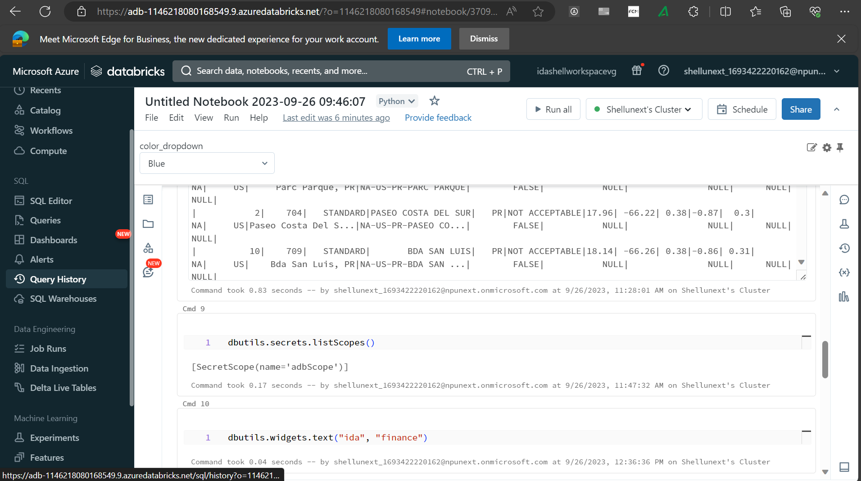

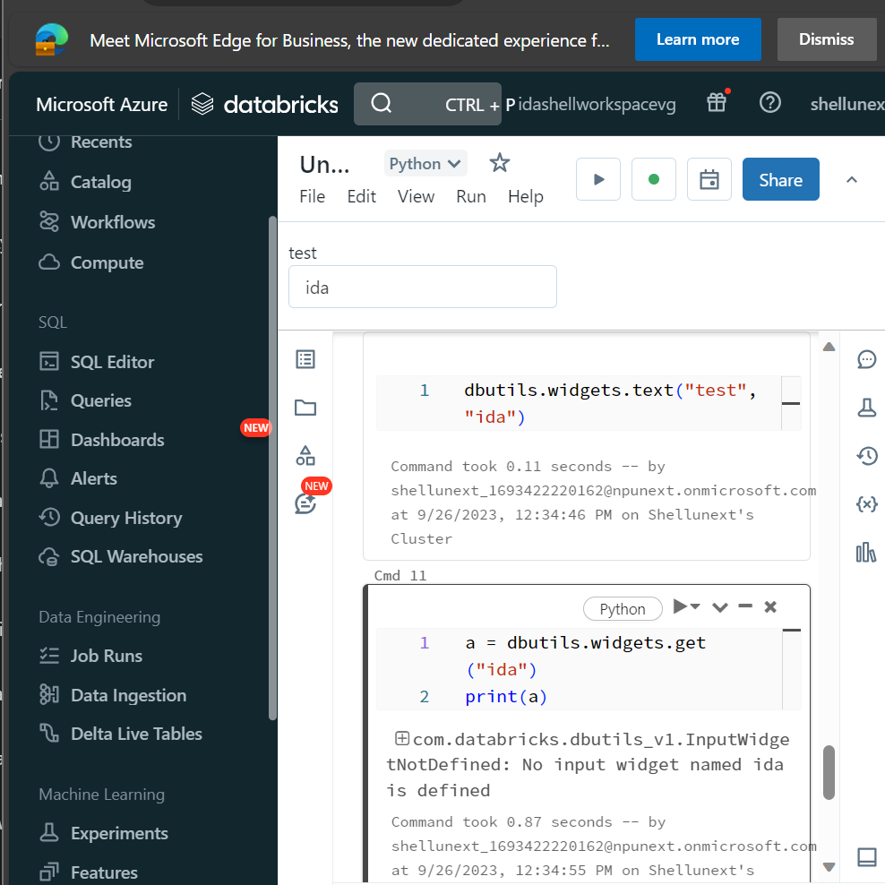

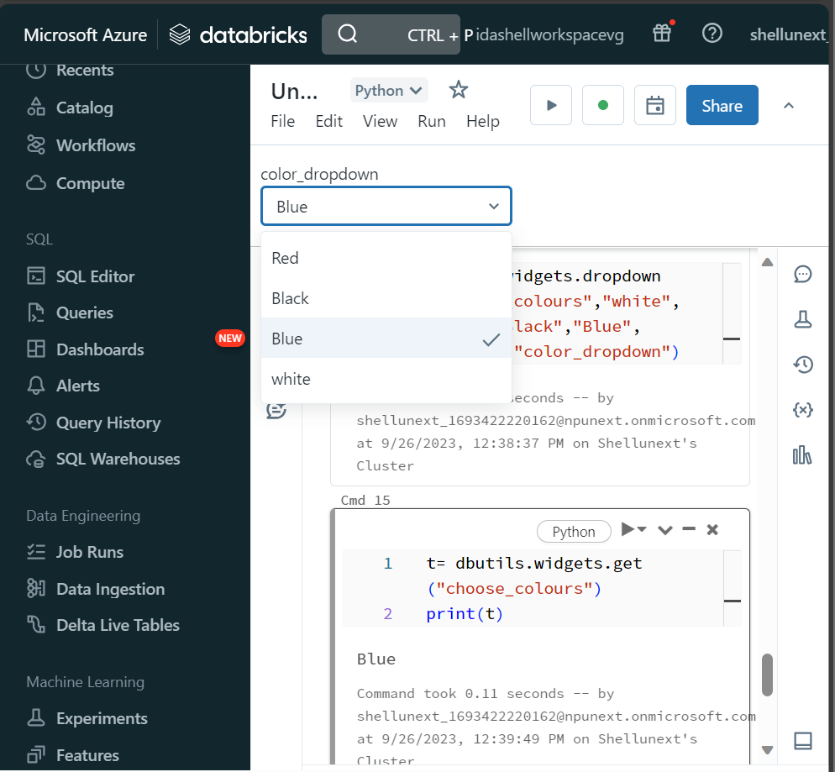

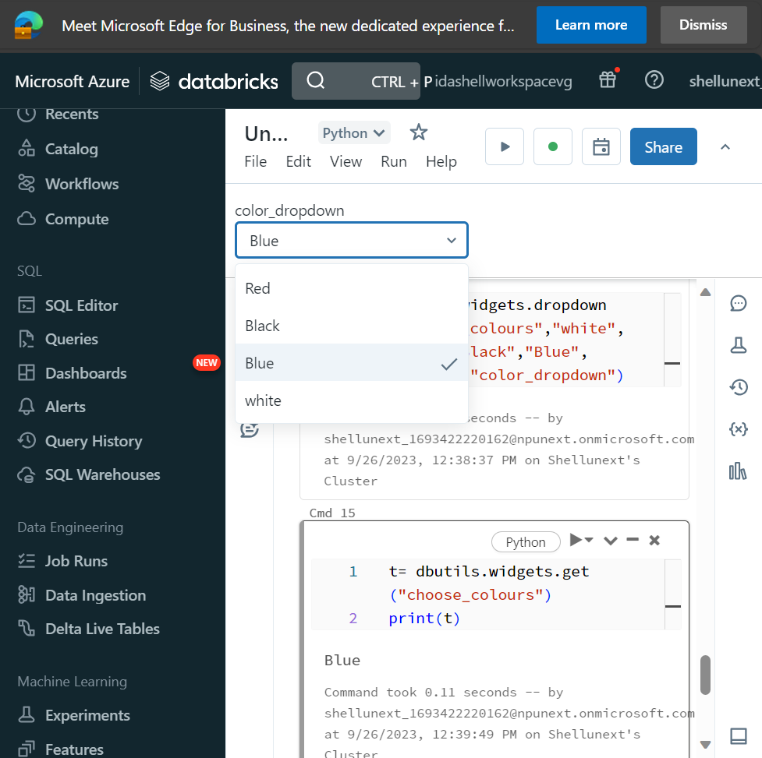

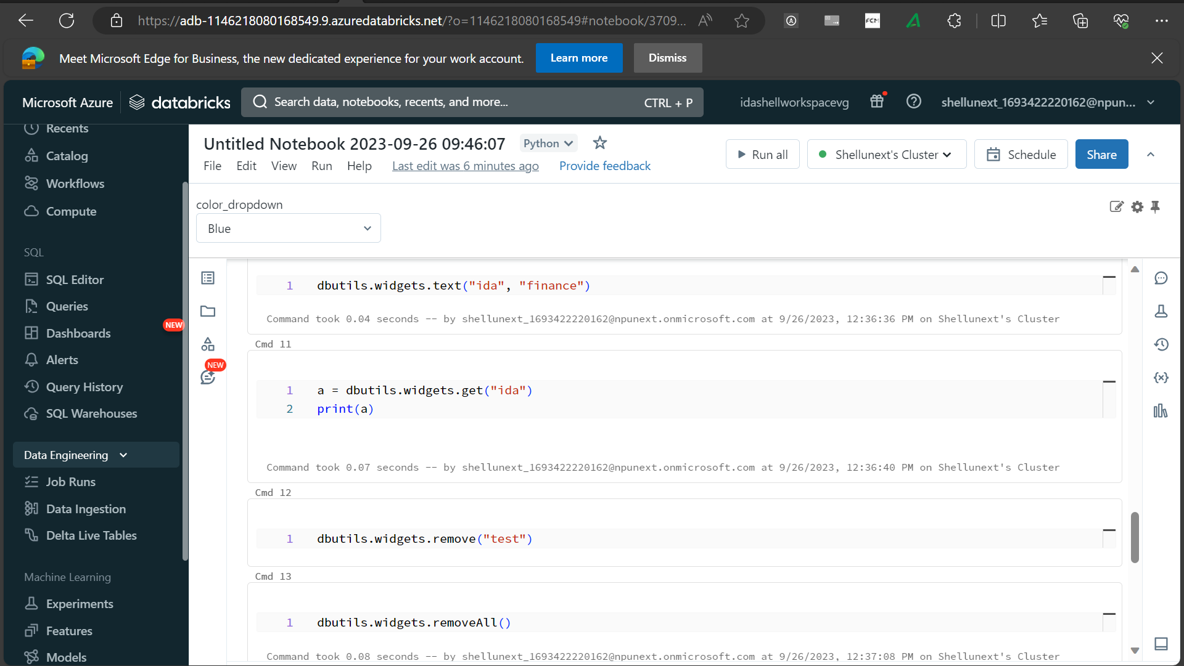

dbutils.widgets.text("test","")

a = dbutils.widgets.get("ida")

print(a)

dbutils.widgets.dropdown("choose_colors","white",["Red","Black","Blue","white"],"color dropdwon")

t = dbutils.widgets.get("choose_colors")

print(t)

dbutils.widgets.combobox("combo_ida","test",["1","2","3"])

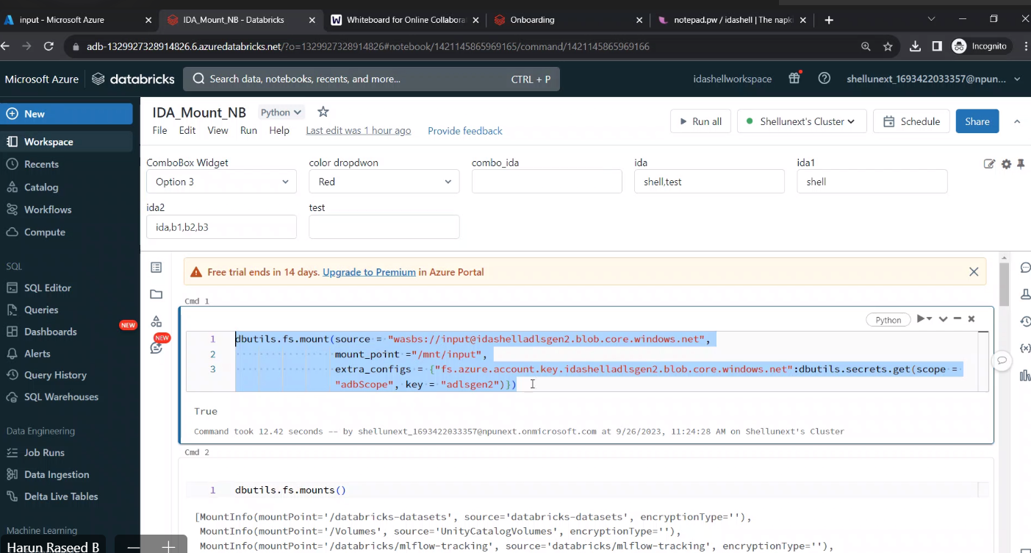

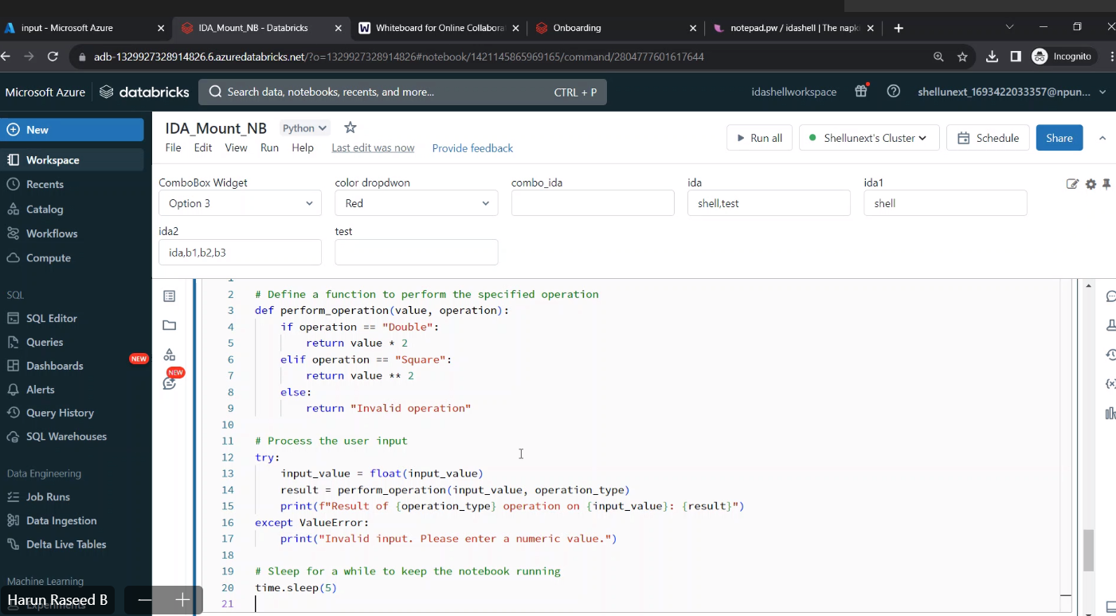

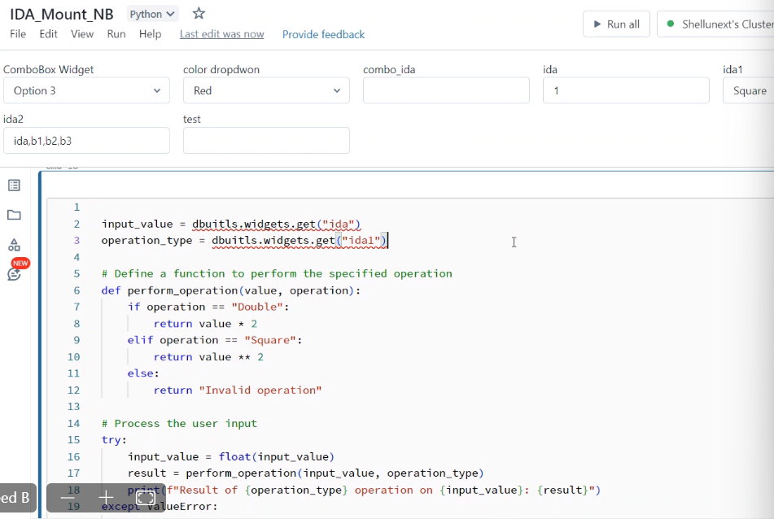

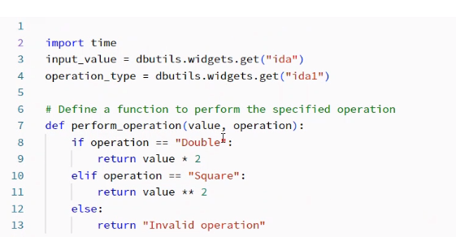

dbutils.widgets.text("test","")

a = dbutils.widgets.get("ida")

print(a)

dbutils.widgets.dropdown("choose_colors","white",["Red","Black","Blue","white"],"color dropdwon")

t = dbutils.widgets.get("choose_colors")

print(t)

dbutils.widgets.combobox("combo_ida","test",["1","2","3"])

bmghNcbolaW1EOx7MI5MNor7XG7Zs0Eb2hE4azGotWam3hIbGJxVtioqDUlSU1tuz1YhKVswwkOd+AStKlXIwQ==

************

dbutils.fs.mount(source = "wasbs://input@idashelladlsgen2.blob.core.windows.net",

mount_point ="/mnt/input",

extra_configs = {"fs.azure.account.key.idashelladlsgen2.blob.core.windows.net":dbutils.secrets.get(scope = "adbScope", key = "adlsgen2")})

**********************************

widget use case

import time

input_value = dbutils.widgets.get("ida")

operation_type = dbutils.widgets.get("ida1")

# Define a function to perform the specified operation

def perform_operation(value, operation):

if operation == "Double":

return value * 2

elif operation == "Square":

return value ** 2

else:

return "Invalid operation"

# Process the user input

try:

input_value = float(input_value)

result = perform_operation(input_value, operation_type)

print(f"Result of {operation_type} operation on {input_value}: {result}")

except ValueError:

print("Invalid input. Please enter a numeric value.")

# Sleep for a while to keep the notebook running

time.sleep(5)

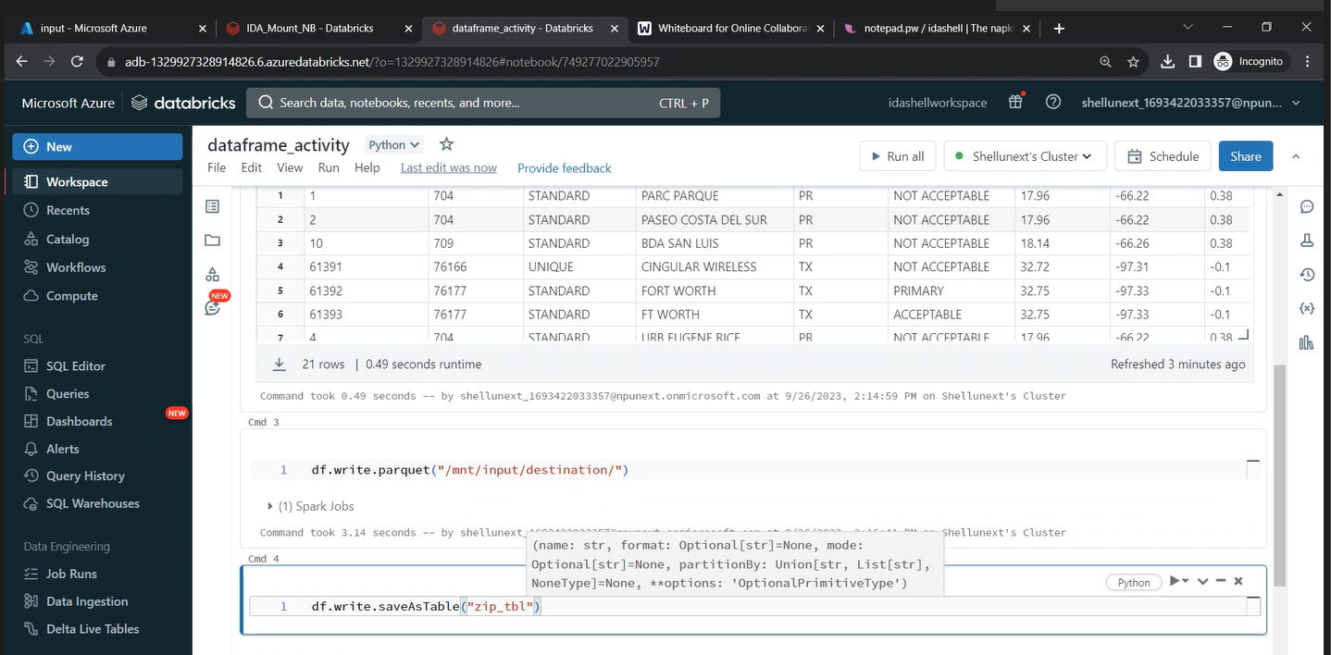

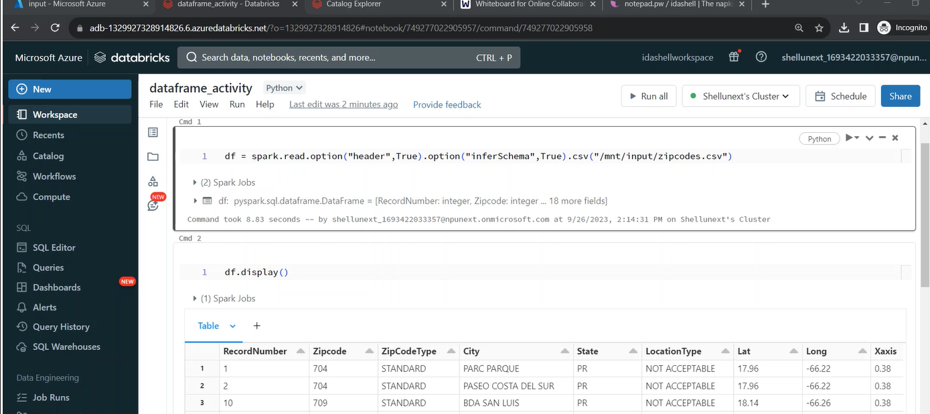

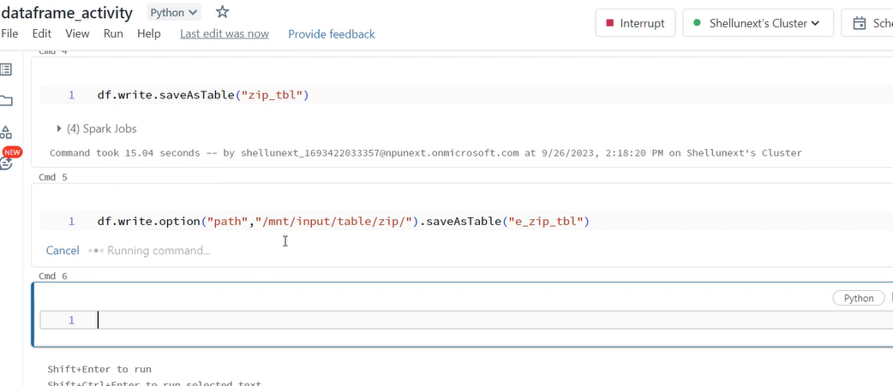

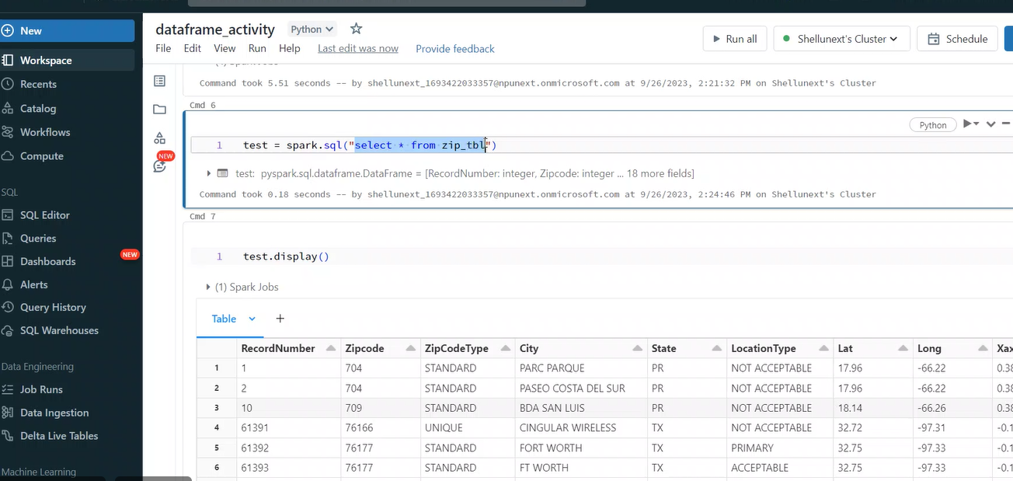

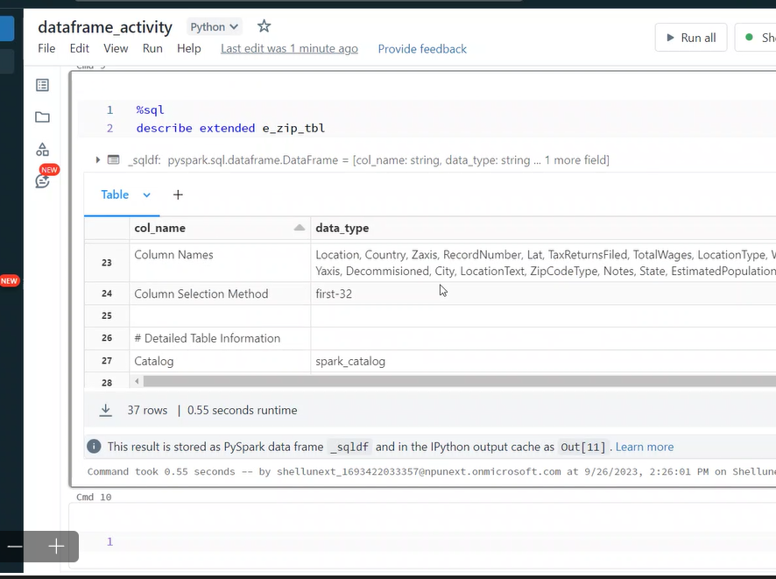

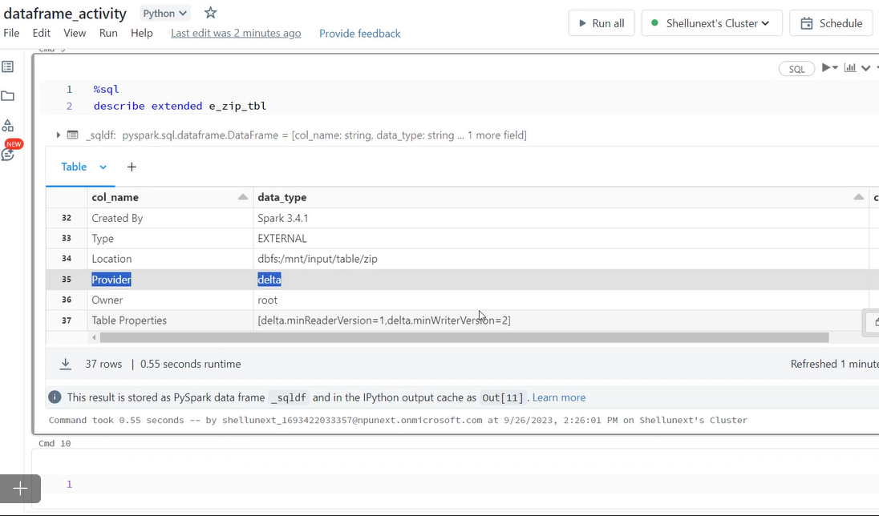

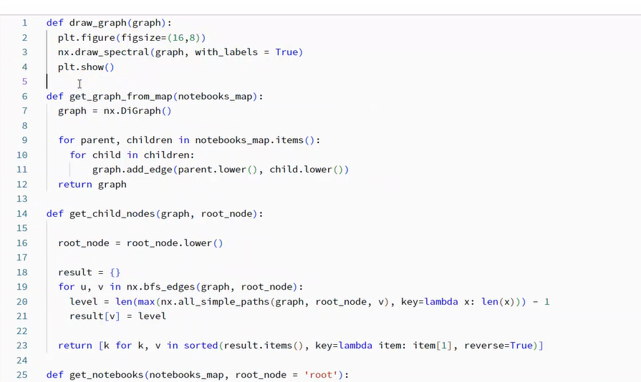

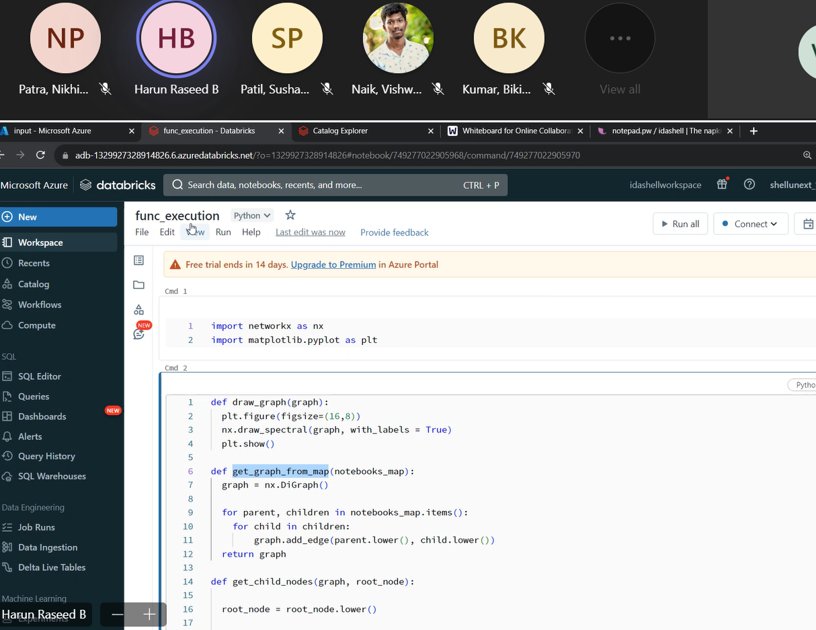

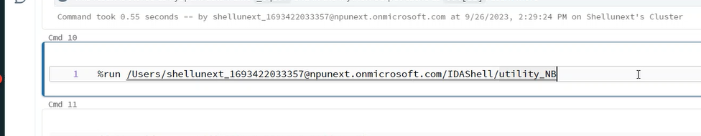

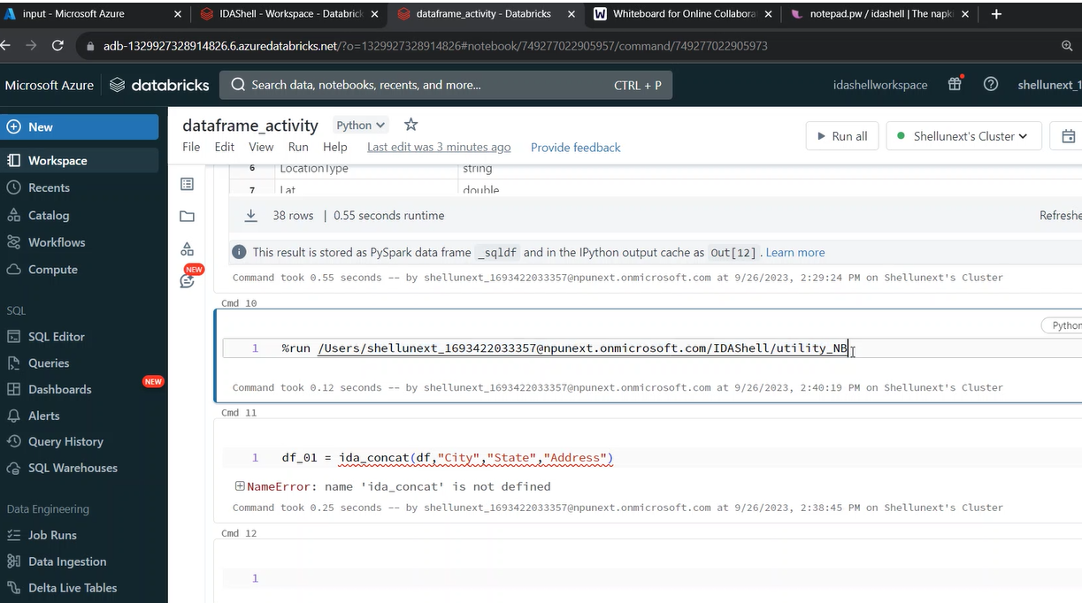

Run it in the first cell

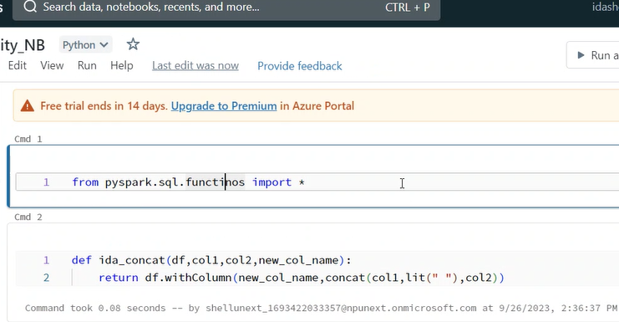

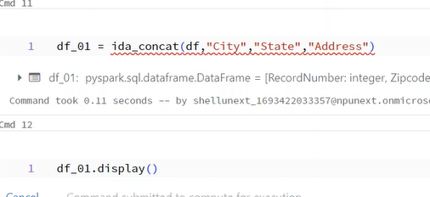

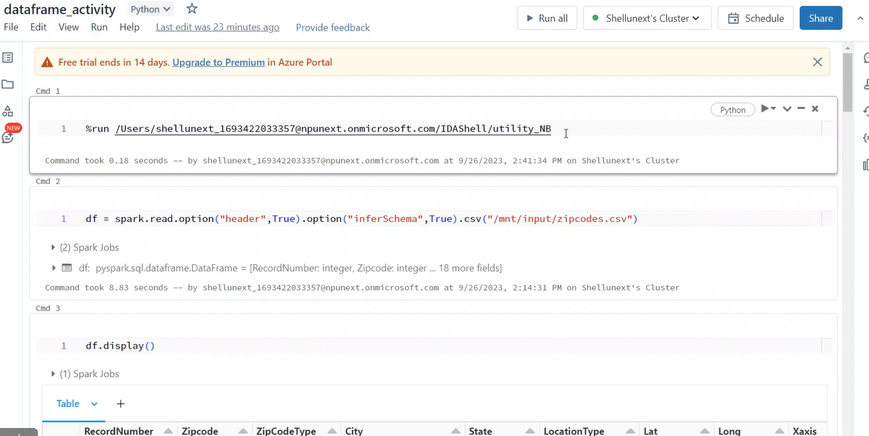

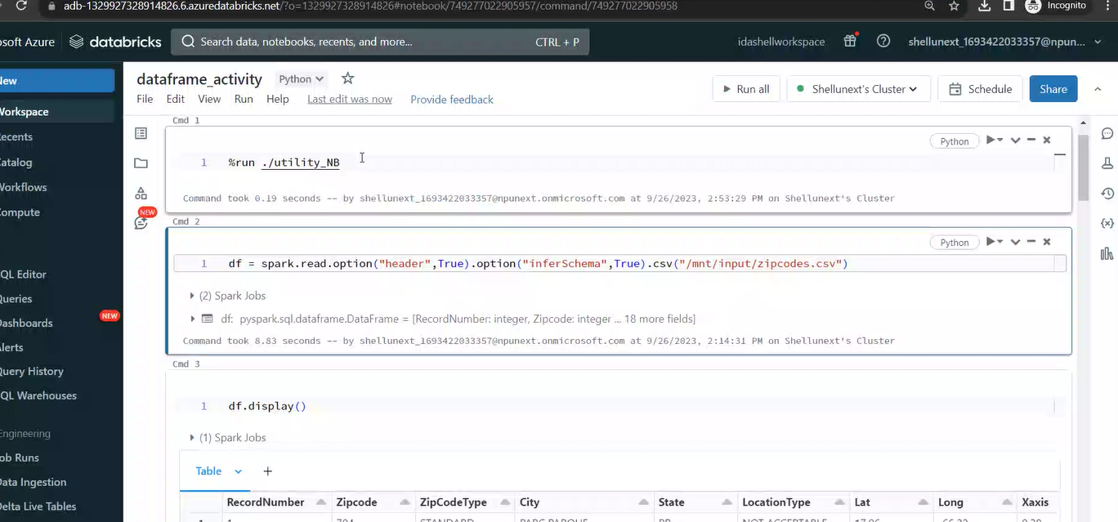

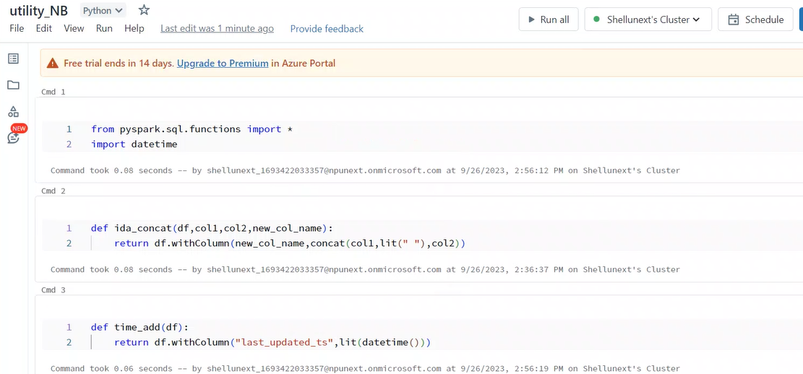

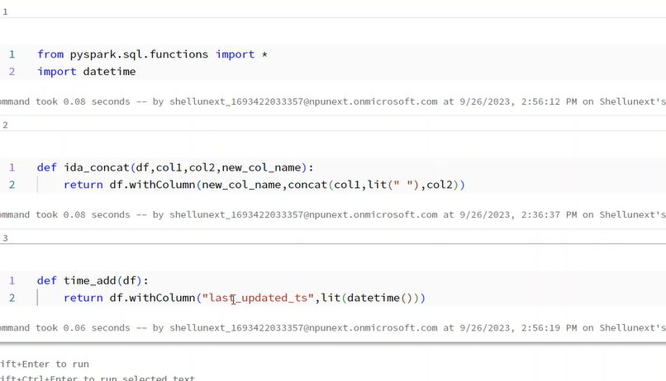

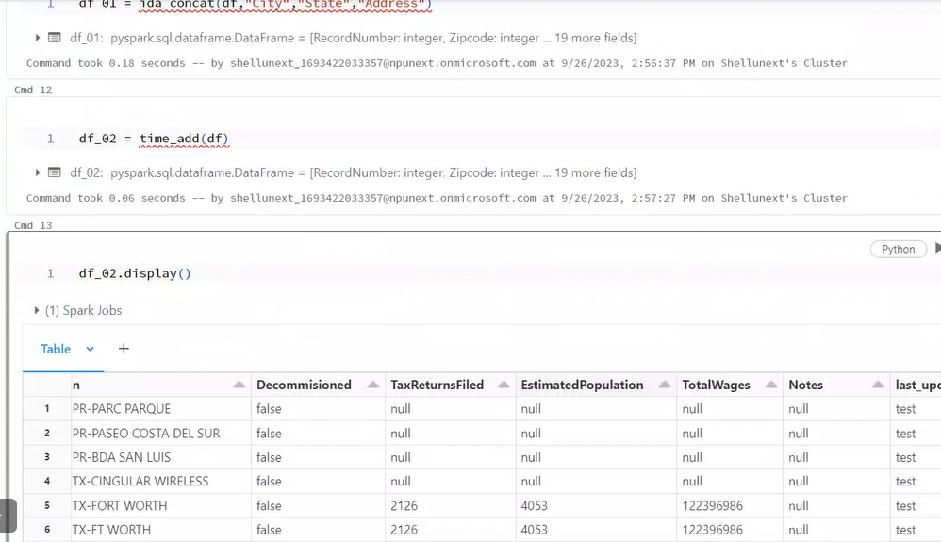

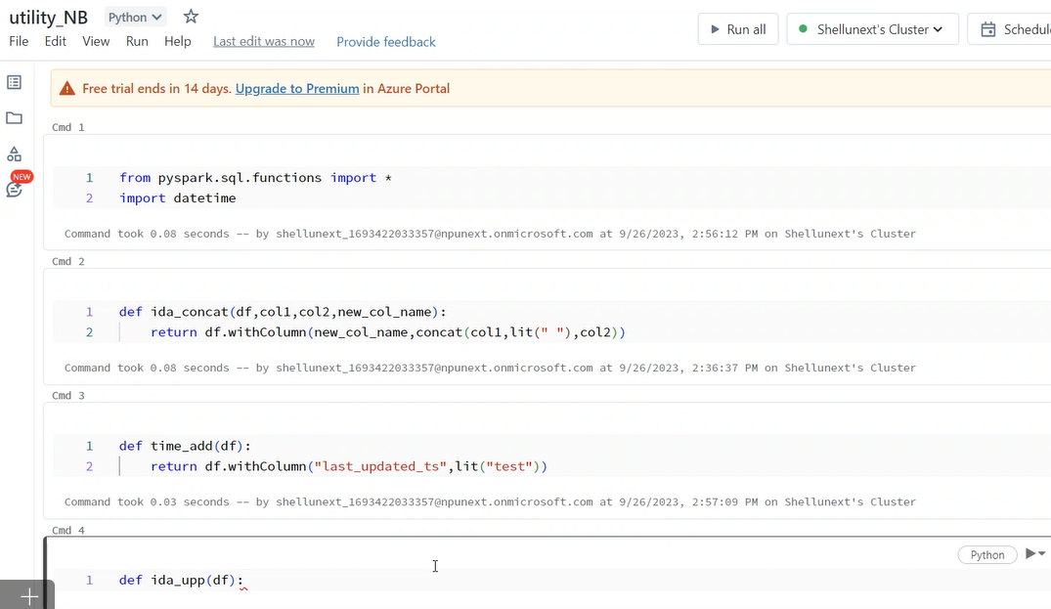

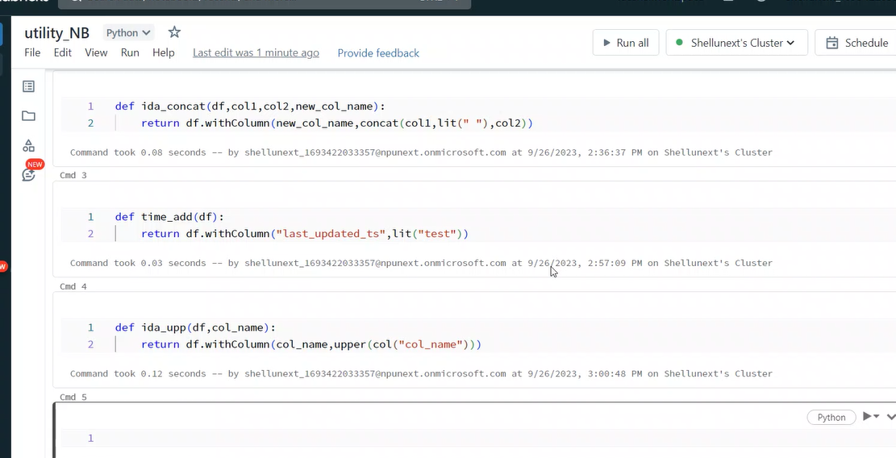

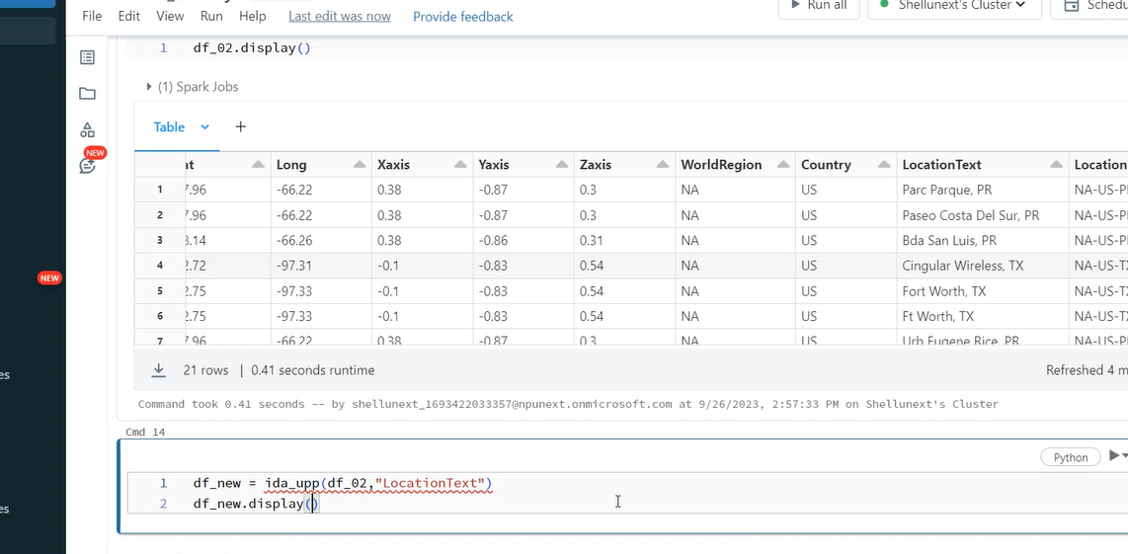

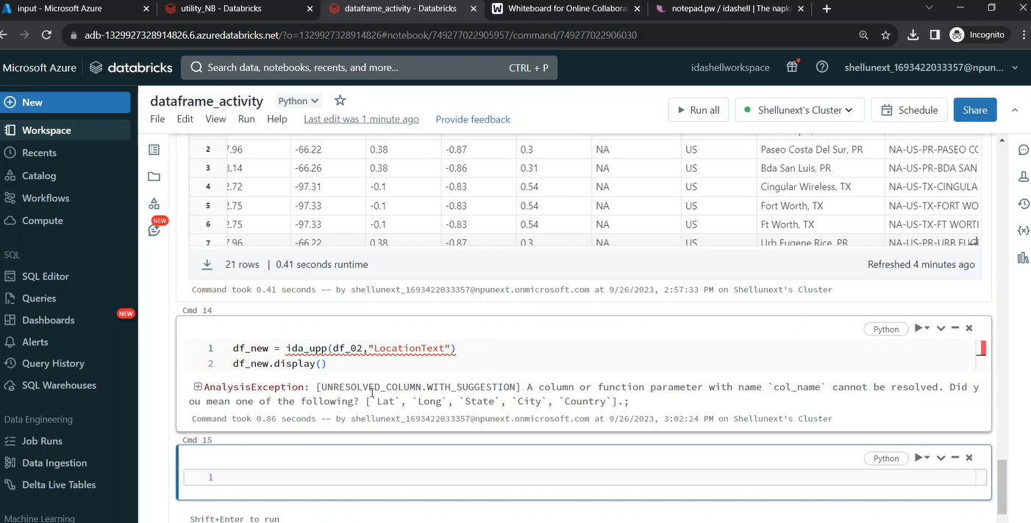

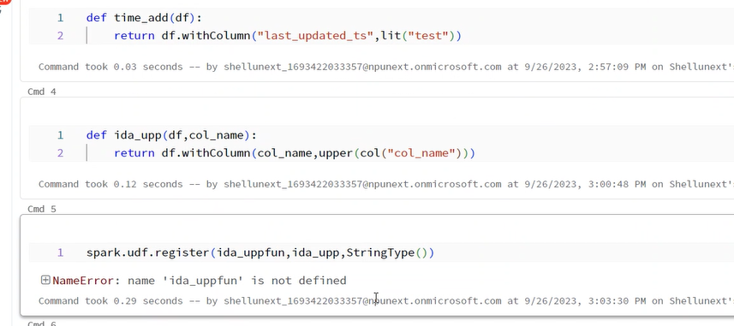

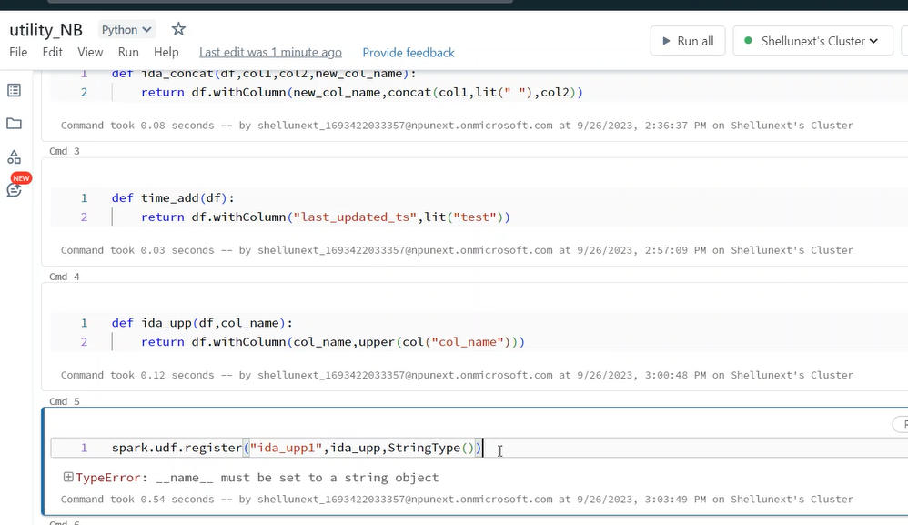

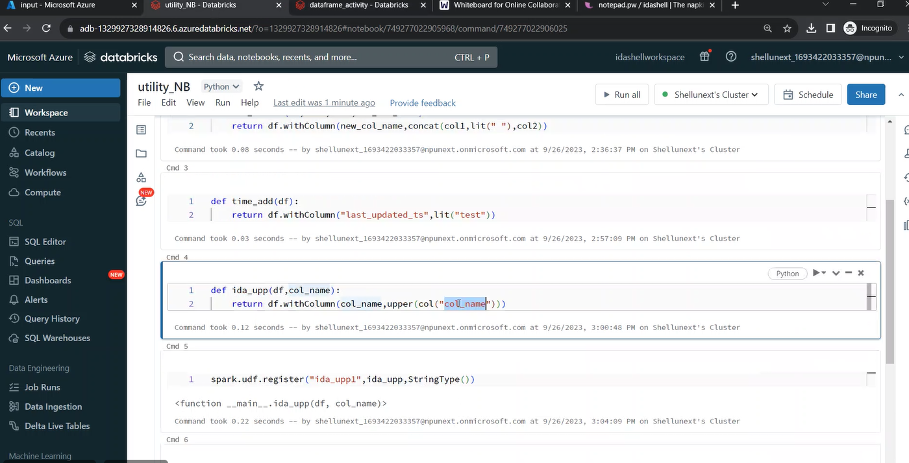

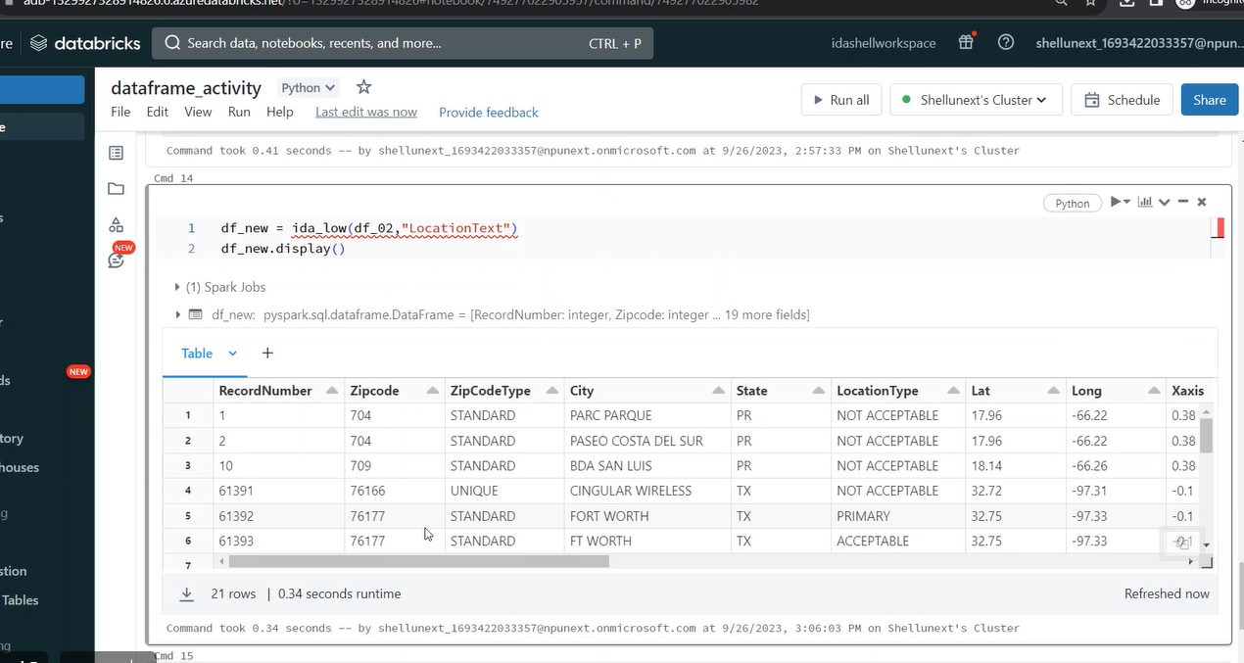

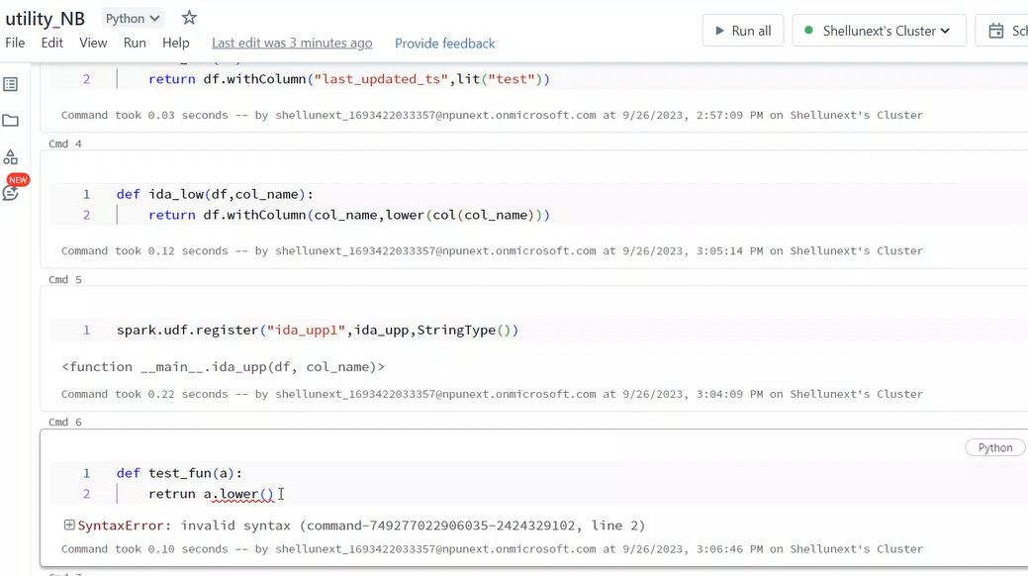

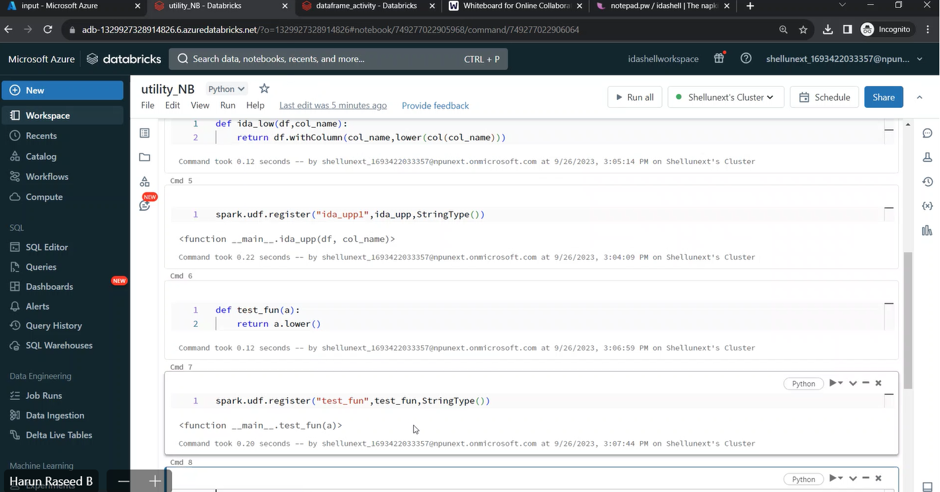

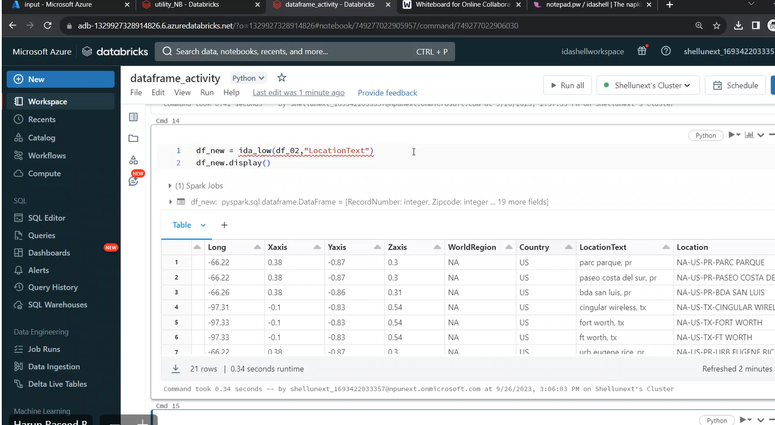

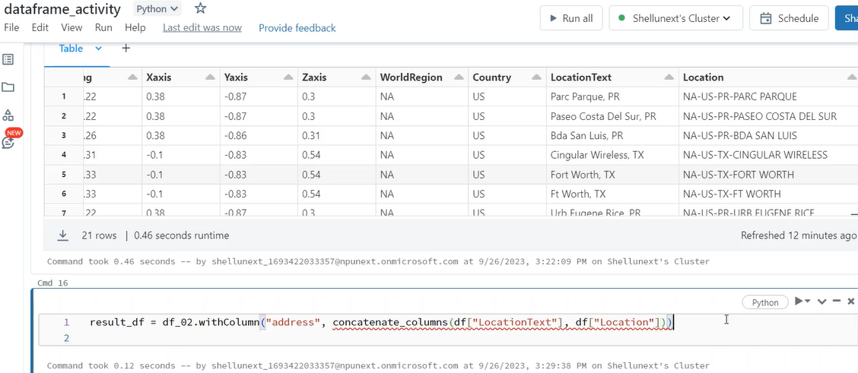

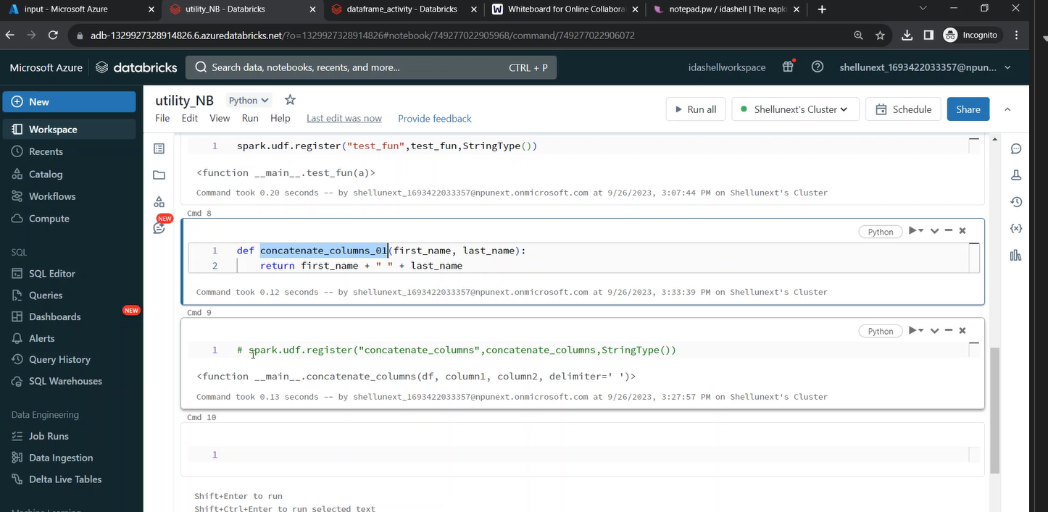

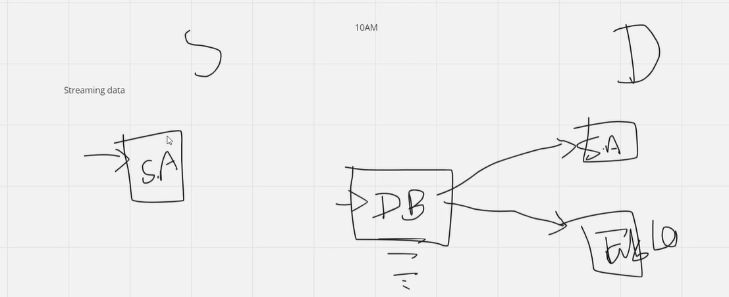

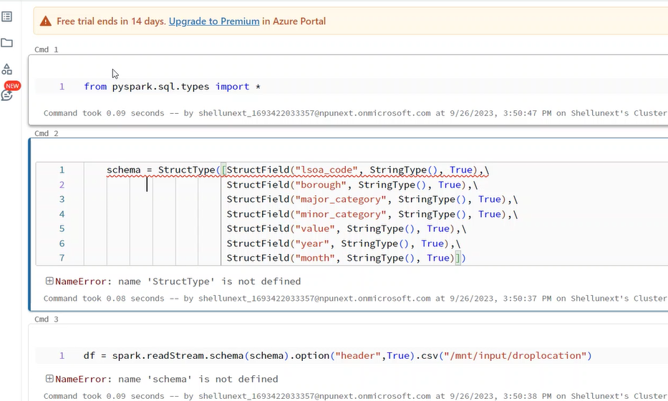

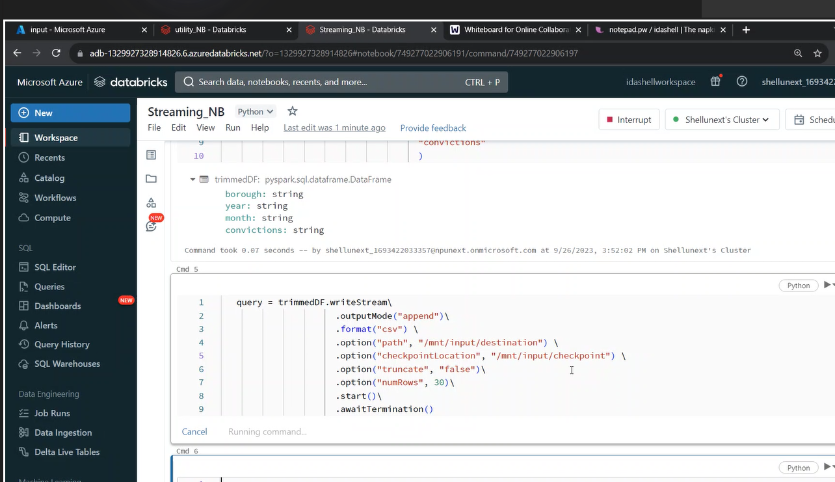

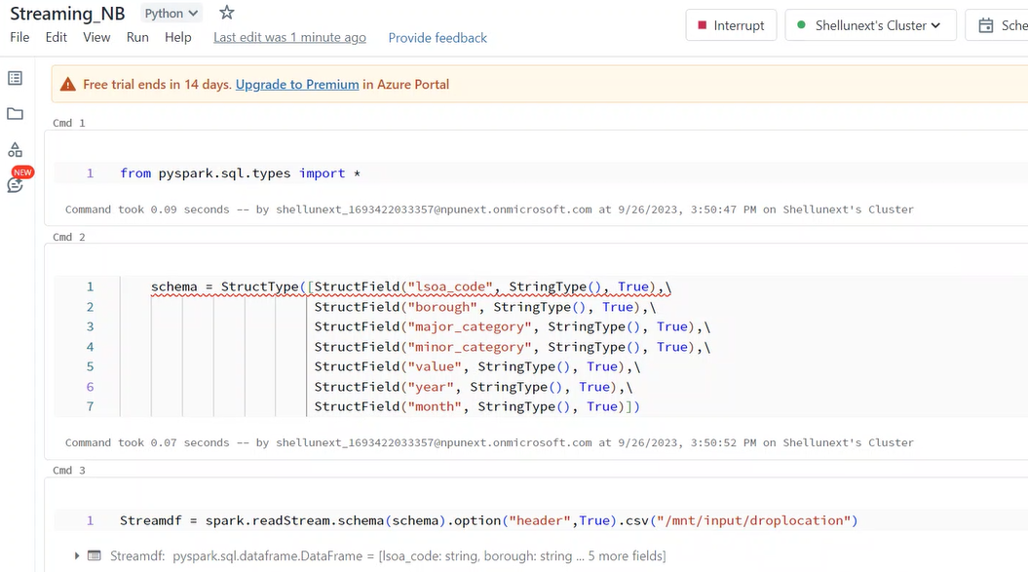

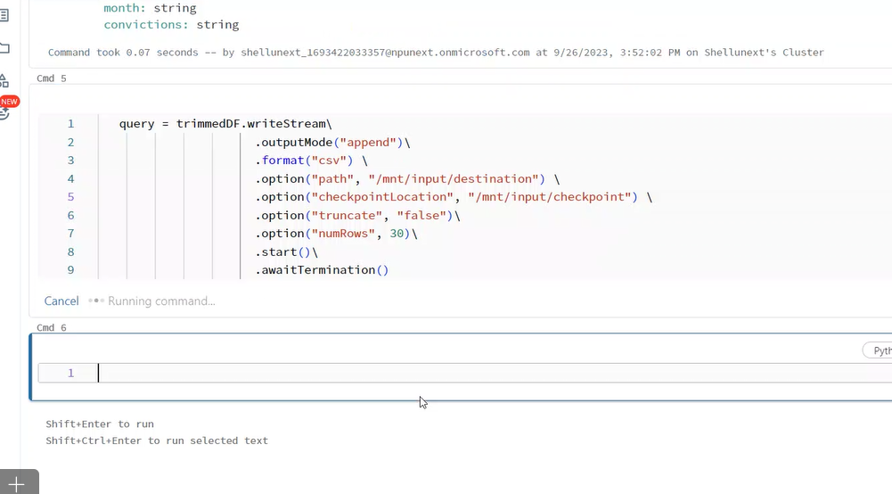

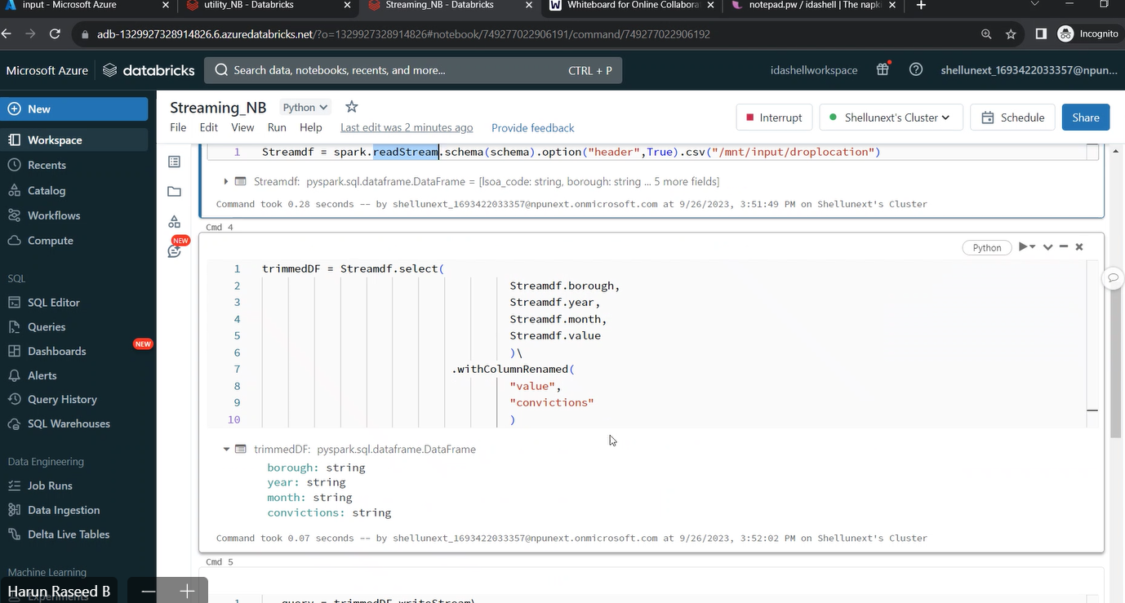

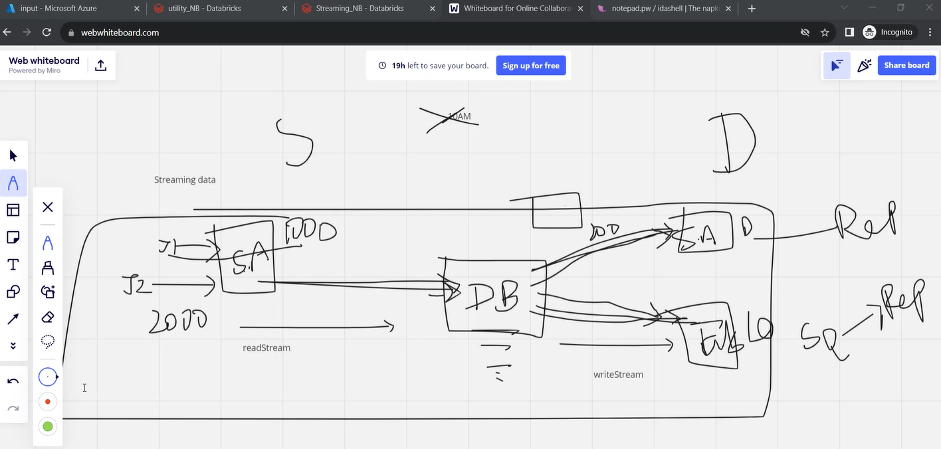

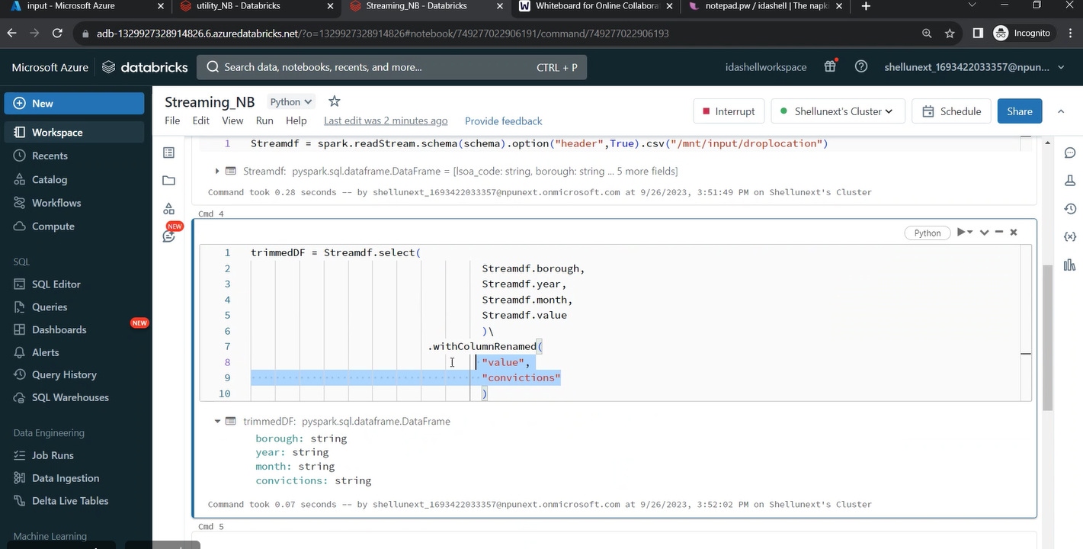

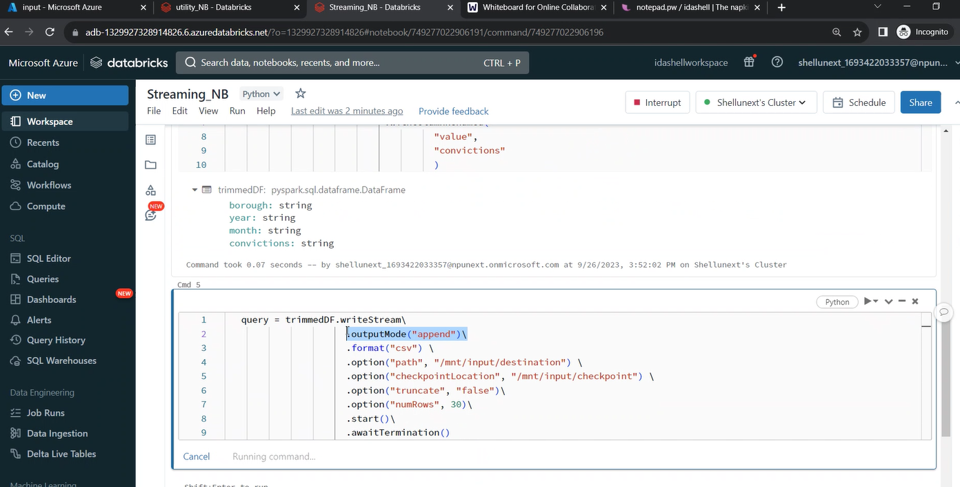

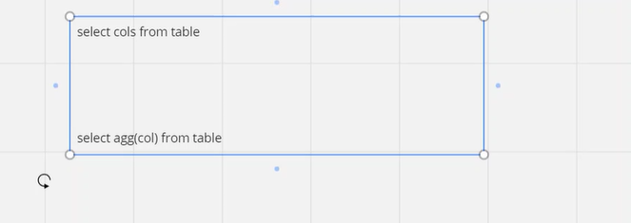

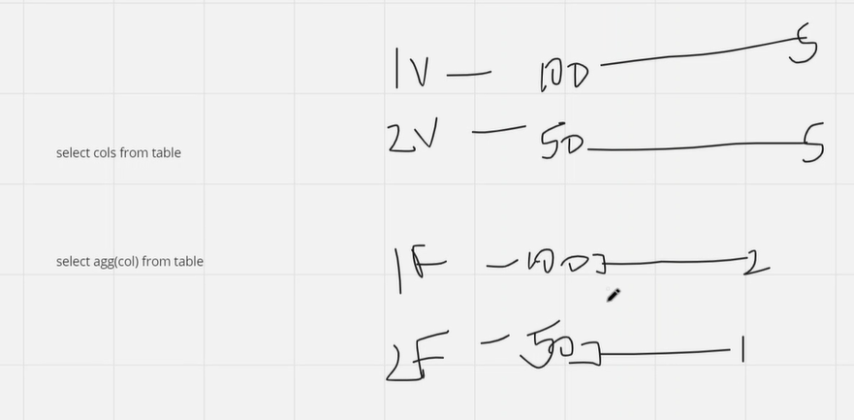

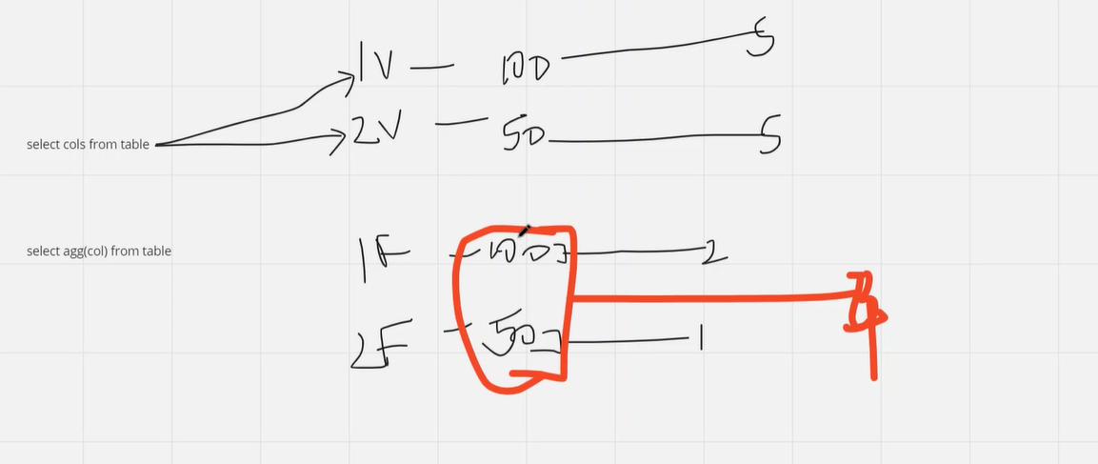

dbutils.widgets.text("test","")

a = dbutils.widgets.get("ida")

print(a)

dbutils.widgets.dropdown("choose_colors","white",["Red","Black","Blue","white"],"color dropdwon")

t = dbutils.widgets.get("choose_colors")

print(t)

dbutils.widgets.combobox("combo_ida","test",["1","2","3"])

bmghNcbolaW1EOx7MI5MNor7XG7Zs0Eb2hE4azGotWam3hIbGJxVtioqDUlSU1tuz1YhKVswwkOd+AStKlXIwQ==

************

dbutils.fs.mount(source = "wasbs://input@idashelladlsgen2.blob.core.windows.net",

mount_point ="/mnt/input",

extra_configs = {"fs.azure.account.key.idashelladlsgen2.blob.core.windows.net":dbutils.secrets.get(scope = "adbScope", key = "adlsgen2")})

**********************************

widget use case

import time

input_value = dbutils.widgets.get("ida")

operation_type = dbutils.widgets.get("ida1")

# Define a function to perform the specified operation

def perform_operation(value, operation):

if operation == "Double":

return value * 2

elif operation == "Square":

return value ** 2

else:

return "Invalid operation"

# Process the user input

try:

input_value = float(input_value)

result = perform_operation(input_value, operation_type)

print(f"Result of {operation_type} operation on {input_value}: {result}")

except ValueError:

print("Invalid input. Please enter a numeric value.")

# Sleep for a while to keep the notebook running

time.sleep(5)

***************************

Structured Streaming

**

from pyspark.sql.types import *

schema = StructType([StructField("lsoa_code", StringType(), True),\

StructField("borough", StringType(), True),\

StructField("major_category", StringType(), True),\

StructField("minor_category", StringType(), True),\

StructField("value", StringType(), True),\

StructField("year", StringType(), True),\

StructField("month", StringType(), True)])

Streamdf = spark.readStream.schema(schema).option("header",True).csv("/mnt/input/droplocation")

trimmedDF = Streamdf.select(

Streamdf.borough,

Streamdf.year,

Streamdf.month,

Streamdf.value

)\

.withColumnRenamed(

"value",

"convictions"

)

query = trimmedDF.writeStream\

.outputMode("append")\

.format("csv") \

.option("path", "/mnt/input/destination") \

.option("checkpointLocation", "/mnt/input/checkpoint") \

.start()\

.awaitTermination()

Link for dataset : <https://drive.google.com/drive/folders/1-6Y2kbKjfXwUhbQZiiTPIw_G0ywAtYBl?usp=sharing>

27/9/23

